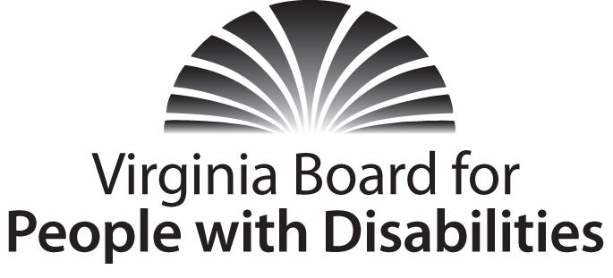

Grant Review Team Meeting – Proposal Review
MINUTES

Date: February 10, 2017

Location: Assistive Technology Loan Fund Authority

Attendees:

Grant Review Team - Board Members:
Mary McAdam
Charles Meacham
Vicki Beatty
Cindy Rudy
Richard Kriner

Board Staff:
Heidi Lawyer
Nia Harrison
Jason Withers

The meeting was called to order at 10:01 AM. At that time, Mary McAdam was selected to lead the Grant Review Team discussion. Mary moved that the Grant Review Team convene in closed session pursuant to Section 2.2-3711A(29) of the Code of Virginia to review the proposal applications submitted in response to the Board’s FFY 2016-2017 Request for Proposals. Charles Meacham seconded the motion. The motion was unanimously APPROVED.

The meeting adjourned at 3:13 PM

