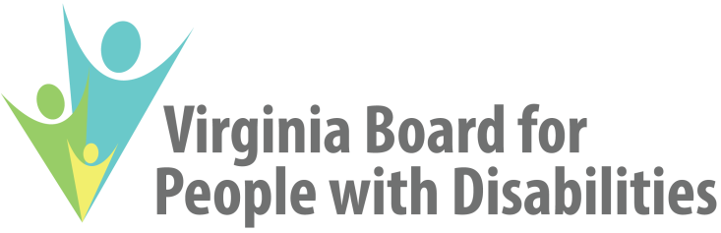

NOMINATIONS COMMITTEE MEETING AGENDA

Date: April 16, 2018

Time: 3:30 – 4:30 PM

Primary Location: dLCV
1512 Willow Lawn, Suite 100
Richmond, VA, 23230
800-552-3962 or 804-225-2042

Secondary Location: Endependence Center, Inc.
6300 E Virginia Beach Blvd
Norfolk, VA, 23502
757-461-8007

Agenda: Selection of slate of officers and at large members for SFY 2018

