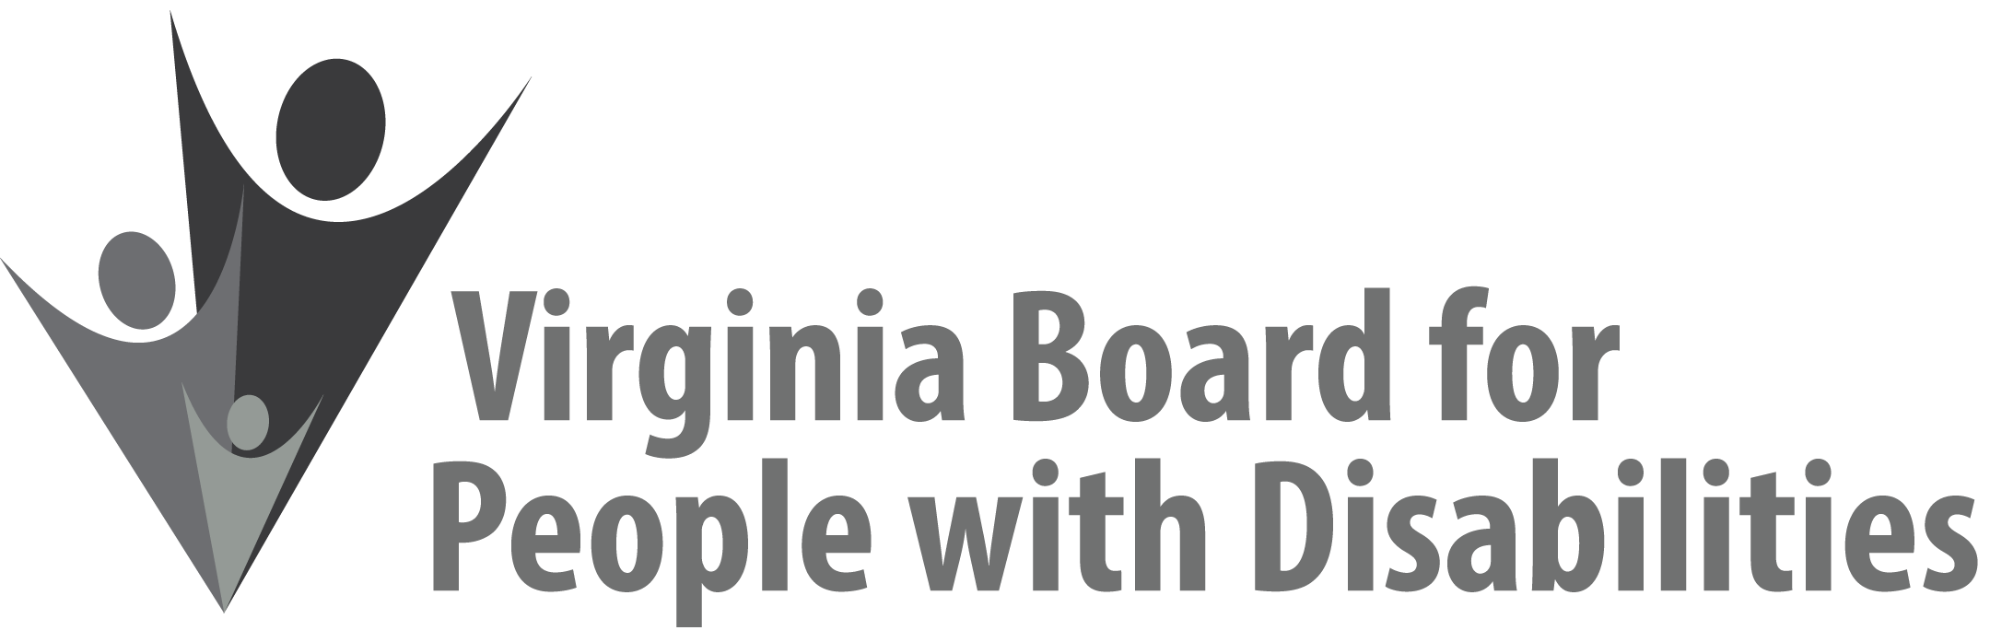

Mission
To create a Commonwealth that advances opportunities for independence, personal
decision-making and full participation in community life for individuals
with developmental and other disabilities.

Vision
Virginians with developmental and other disabilities direct their own lives
and choose how they live, learn, work, and play.

BOARD MEETING AGENDA

September 13, 2017 Four Points by Sheraton Hotel
4700 S. Laburnum Avenue, Richmond, VA 23231

8:00am - 9:00am Executive Committee (see Attachment EC 1)

8:30 - 9:00 Coffee/Continental breakfast– Ballrooms - Monet D & E

9:15– 11:15 COMMITTEE MEETINGS
Advocacy, Outreach, and Training, Renoir A
Investment and State Plan Oversight – Renoir B
Policy, Research, and Evaluation – Renoir C

11:30 Lunch – Ballrooms D & E
11:45 PRESENTATION, Individual and Family Support Program, Bob Villa,
Department of Behavioral Health and Developmental Services

12:45pm FULL BOARD CONVENES – Ballrooms D & E
12:45 Welcome, Call to Order, and Introductions of New Board members
Mary McAdam
1:00 Approval of June 7, 2017 Board meeting minutes, ACTION REQUIRED
(Attachment BD 1), Mary McAdam
1:05 Public Comment
1:15 Standing Committee Reports:
Questions on Executive Committee meeting
Report of the Advocacy and Outreach Committee, ACTION REQUIRED
(Attachment BD 2 & BD 3)
Report of the Policy, Research & Evaluation Committee, Summer Sage
Report of the Investment & State Plan Oversight Committee, ACTION REQUIRED (Supplemental Packet)
1:45 PRESENTATION: DD Waiver Implementation Update, Deana Parker, Senior
DD Policy Analyst, DBHDS
2:45 Agency and organizational updates
3:30 Other Business
3:45 Board Adjourns

