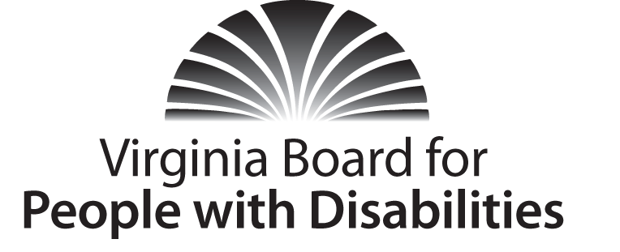
Mission
To create a Commonwealth that advances opportunities for independence, personal decision-making and full participation in community life for individuals with developmental and other disabilities.
Vision
Virginians with developmental and other disabilities direct their own lives and
choose how they live, learn, work, and play.

BOARD MEETING AGENDA

September 20, 2016 - Four Points by Sheraton Hotel
4700 S. Laburnum Avenue, Richmond, VA 23231

7:45am - 9:00am Executive Committee (see Attachment EC 1)

8:30 - 9:00 Coffee/Continental breakfast– Ballrooms - Monet D & E

9:15– 11:15 COMMITTEE MEETINGS
Advocacy, Outreach, and Training, Renoir A
Investment and State Plan Oversight – Renoir B
Policy, Research, and Evaluation – Renoir C

11:30 Lunch – Ballrooms D & E – Reflections from YLF and PIP Graduates

12:30 pm FULL BOARD CONVENES – Ballrooms D & E
12:35 Welcome, Call to Order, and Introductions of New Board members
Charles Meacham
12:45 Approval of June 15, 2016 Board meeting minutes, ACTION REQUIRED
(Attachment BD 1), Charles Meacham
12:50 Public Comment
1:00 Standing Committee Reports:
Questions on Executive Committee meeting, ACTION REQUIRED, (Attachment EC 6), Charles Meacham
Report of the Advocacy and Outreach Committee, ACTION REQUIRED,
(Attachments BD 2, BD 3, & BD 4) Randy Burak
Report of the Policy, Research & Evaluation Committee, Angela Yong West
Report of the Investment & State Plan Oversight Committee, ACTION REQUIRED (Supplemental Packet) Cindy Rudy
1:45 PRESENTATION: Center for Transition Innovations, Dr. Elizabeth Getzel
Director, Center for Transition Innovations, Virginia Commonwealth
University; Dr. Marianne Moore, Transition Coordinator, Virginia Department
of Education
2:15 Agency and organizational updates
3:00 Other Business
3:15 Board Adjourns

