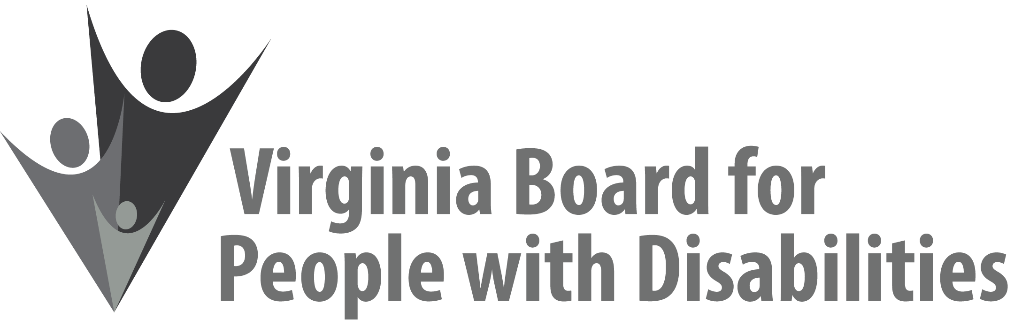
Mission
To create a Commonwealth that advances opportunities for independence, personal
decision-making and full participation in community life for individuals
with developmental and other disabilities.

Vision
Virginians with developmental and other disabilities direct their own lives
and choose how they live, learn, work, and play.

BOARD MEETING AGENDA

December 5, 2018
Four Points by Sheraton Hotel, 4700 S. Laburnum Avenue, Richmond, VA, 23231

8:00am - 9:15 am Executive Committee (see Attachment EC 1)

8:30 - 9:15 Coffee/Continental breakfast– Ballrooms - Monet D & E

9:30– 11:30 COMMITTEE MEETINGS
Advocacy, Outreach, and Training, Renoir A
Investment and State Plan Oversight – Renoir B
Policy, Research, and Evaluation – Renoir C

11:45 Lunch – Ballrooms D & E
Presentation: Virginia Hospital Research Education Foundation (VHREF), Early Intervention NICU Grant Outcomes

1:00pm FULL BOARD CONVENES – Ballrooms D & E
1:05 Welcome and Call to Order, Mary McAdam
1:10 Approval of September 12, 2018, Board meeting minutes, ACTION REQUIRED (Attachment BD 1), Mary McAdam
1:15 Public Comment
1:25. Approval of revised SFY 2018 Board Operational Budget, ACTION REQUIRED, (Supplemental Packet 1)
1:40 Standing Committee Reports:
Report of the Advocacy and Outreach Committee, ACTION REQUIRED, (Attachment BD 3)
Report of the Policy, Research & Evaluation Committee, Felicia Hamilton
Report of the Investment & State Plan Oversight Committee, Theresa Casselman
Approval of the FFY 2019 State Plan Update, ACTION REQUIRED (Attachment BD 2)
Approval of FFY 2019 Competitive RFP-Round 2, ACTION
REQUIRED (Supplemental Packet 2)
2:40 Agency and organizational updates
3:30 Other Business
3:45 Board Adjourns

