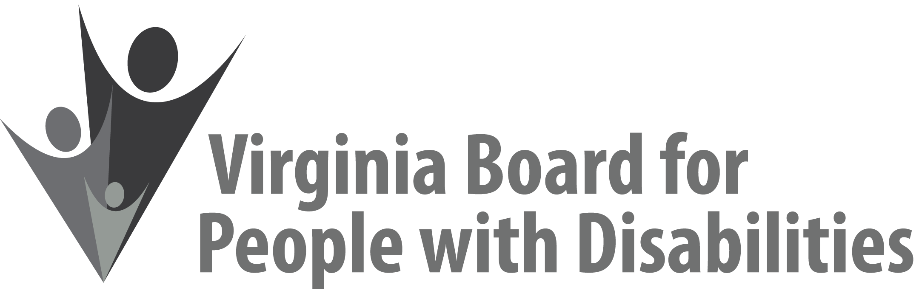

Mission
To create a Commonwealth that advances opportunities for independence, personal
decision-making and full participation in community life for individuals
with developmental and other disabilities.

Vision
Virginians with developmental and other disabilities direct their own lives
and choose how they live, learn, work, and play.

EXECUTIVE COMMITTEE AGENDA

December 5, 2018
8:00 am - 9:15 am Renoir C

8:00 Call to Order and welcomes, Mary McAdam
8:05 Review of Executive Committee Meeting Agenda (Attachment EC 1),
Mary McAdam
8:10 Approval of Minutes of September 12, 2018 Executive Committee
ACTION REQUIRED (Attachment EC 2), Mary McAdam
8:13 Board Member Attendance (Attachment EC 3), Jamie Snead
8:16 Questions on Executive Director’s Update (Attachment EC 4), Heidi Lawyer
8:25 Questions on Agency Fiscal Reports (Attachments EC 5), John Cimino
8:35 Presentation and approval of revised SFY 2019 Budget, ACTION REQUIRED (Supplemental Packet 1)
8:50 Questions on Grant Expenditure Update (Attachment ISP 4), Jason Withers
9:00 Approval of Competitive RFP – Round 2 (Supplemental Packet 2), Jason Withers
9:10 Committee agendas, Committee Chairs/Staff
9:13 Other business
9:15 Adjourn

