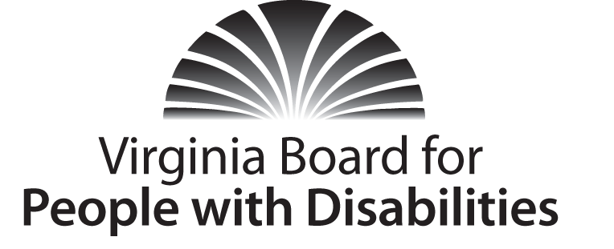
Mission
To create a Commonwealth that advances opportunities for independence, personal decision-making and full participation in community life for individuals with developmental and other disabilities.
Vision
Virginians with developmental and other disabilities direct their own lives and
choose how they live, learn, work, and play.

BOARD MEETING AGENDA

December 14, 2016 - Four Points by Sheraton Hotel
4700 S. Laburnum Avenue, Richmond, VA 23231

8:00am - 9:05am Executive Committee (see Attachment EC 1)

8:30 - 9:00 Coffee/Continental breakfast– Ballrooms - Monet D & E

9:15– 11:15 COMMITTEE MEETINGS
Advocacy, Outreach, and Training, Renoir A
Investment and State Plan Oversight – Renoir B
Policy, Research, and Evaluation – Renoir C

11:30 Lunch – Ballrooms D & E – Presentation by VCU Partnership for People with Disabilities on LEAP Grant – Molly Dellinger-Wray, Project Director and Jack Brandt, Disability Policy Specialist

12:30 pm FULL BOARD CONVENES – Ballrooms D & E
12:35 Welcome, Call to Order, Charles Meacham
12:45 Approval of September 20, 2016 Board meeting minutes, ACTION REQUIRED
(Attachment BD 1), Charles Meacham
12:50 Public Comment
1:00 Approval of Public Comment Policy, ACTION REQUIRED (Attachment BD 2)
1:10 Standing Committee Reports and Discussion:
Questions on Executive Committee meeting, Charles Meacham
Report of the Advocacy and Outreach Committee, Randy Burak
Report of the Policy, Research & Evaluation Committee, Angela Yong West
Report of the Investment & State Plan Oversight Committee, Cindy Rudy
1:55 Review of Consumer Satisfaction Survey Results, (Attachment BD 3),
Ben Jarvela
2:05 FFY 2017-2021 State Plan Amendment Approval, ACTION REQUIRED
(Attachment BD 4)
2:10 Review/Questions on 2017-2021 State Plan
2:30 Agency and organizational updates/discussion
3:25 Other Business
3:30 Board Adjourns

