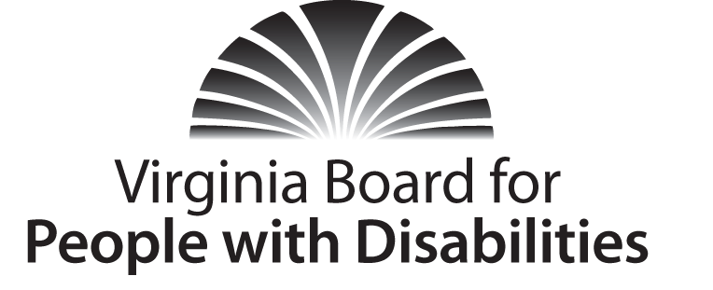
Mission
To create a Commonwealth that advances opportunities for independence, personal decision-making and full participation in community life for individuals with developmental and other disabilities.
Vision
Virginians with developmental and other disabilities direct their own lives and
choose how they live, learn, work, and play.

BOARD MEETING AGENDA

Wednesday, March 18, 2015 - Four Points by Sheraton Hotel
4700 S. Laburnum Avenue, Richmond, VA 23231

7:45am - 9:15am Executive Committee (see Attachment EC-1)

8:30 - 9:30 Coffee/Continental breakfast– Ballrooms - Monet D & E

9:30 – 10:45 COMMITTEE MEETINGS
Advocacy & Outreach – Renoir B
Community Integration – Renoir A
Community Living & Transportation -*Library*
Education & Employment – Renoir C

11:00 FULL BOARD CONVENES – Ballrooms D & E
11:05 Welcome and Call to Order, Korinda Rusinyak
11:15 Approval of December 3, 2014 Board meeting minutes, Action Required
(Attachment BD 1), Korinda Rusinyak
11:20 Executive Committee Report, Dennis Manning
11:30 Public Comment
11:40 Approval of Board operating policy change, Action Required
Attachment BD 2), Korinda Rusinyak
11:50 Appointment of Nominations Committee, (Attachment BD 3)
Korinda Rusinyak
11:55 Agency Updates on policy, budget, programs
12:30 Lunch – Ballrooms D & E – Presentation (grant project) - Oral Health for Adults with Developmental Disabilities - Katherine Libby, Program Manager, Virginia Oral Health Coalition

1:45 Standing Committee Reports:

Report of the Advocacy and Outreach Committee

Report of the Community Integration Committee
Report of the Community Living & Transportation Committee
Report of the Education and Employment Committee

2:00 Presentation: DD Councils: Meeting Priorities in Lean Budget Times, Donna Meltzer, CEO, National Association of Councils on Developmental Disabilities.

3:45 Agency Updates on policy, budget and programs, Agency designees
4:15 Other Business
4:30 Board Adjourns

Upcoming Meetings:
June 3, 2015
September 9, 2015
December 2, 2015

