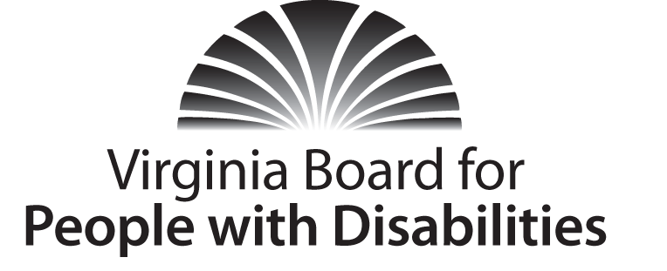
Mission
To create a Commonwealth that advances opportunities for independence, personal decision-making and full participation in community life for individuals with developmental and other disabilities.
Vision
Virginians with developmental and other disabilities direct their own lives and
choose how they live, learn, work, and play.

BOARD MEETING AGENDA

Wednesday, March 16, 2016 - Four Points by Sheraton Hotel
4700 S. Laburnum Avenue, Richmond, VA 23231

8:00am - 9:00am Executive Committee (see Attachment EC 1)

8:15 - 9:00 Coffee/Continental breakfast– Ballrooms - Monet D & E

9:05– 11:30 COMMITTEE MEETINGS
Advocacy, Outreach, and Training, Renoir A
Investment and State Plan Oversight – Renoir B
Policy, Research, and Evaluation – Renoir C

11:45 am FULL BOARD CONVENES – Ballrooms D & E
11:50 Welcome, Call to Order, and Introductions, Charles Meacham
12:00 Approval of December 2, 2015 Board meeting minutes, Action Required
(Attachment BD 1), Charles Meacham
12:05 Report of the Nominations Committee (Attachment BD 2), Ron King
12:10 Appointment of Nominations Committee for SFY 2017, Charles Meacham
12:15 Public Comment
12:25 Lunch – Ballrooms D & E – Presentation
Managed Long Term Care Services and Supports, Sarah Broughton, Dept. of Medical Assistance Services
1:30 Standing Committee Reports:
Report of the Advocacy and Outreach Committee, Randy Burak
Report of the Investment & State Plan Oversight Committee, Michael Carrasco
Report of the Policy, Research & Evaluation Committee, Angela Yong
West
Questions on Executive Committee meeting, Charles Meacham
General Comments on new structure
2:15 Discussion of 2017-2021 State Plan public comment as relates to Plan, Action Required (Attachment BD 3 and ISP 4), Charles Meacham
2:45 Agency legislative and budget amendment updates, Agency designees
3:30 Other Business
3:45 Board Adjourns

