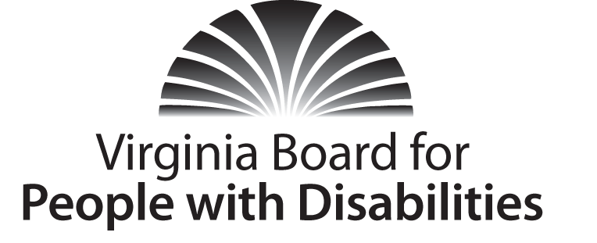
Mission
To create a Commonwealth that advances opportunities for independence, personal decision-making and full participation in community life for individuals with developmental and other disabilities.
Vision
Virginians with developmental and other disabilities direct their own lives and
choose how they live, learn, work, and play.

BOARD MEETING AGENDA

June 15, 2016 - Four Points by Sheraton Hotel
4700 S. Laburnum Avenue, Richmond, VA 23231

7:45am - 9:00am Executive Committee (see Attachment EC 1)

8:30 - 9:00 Coffee/Continental breakfast– Ballrooms - Monet D & E

9:15– 11:30 COMMITTEE MEETINGS
Advocacy, Outreach, and Training, Renoir A
Investment and State Plan Oversight – Renoir B
Policy, Research, and Evaluation – Renoir C

11:45 Lunch – Ballrooms D & E – Presentation: CMS Home and Community Based Final Rule, Teri Morgan, Program Supervisor, Dept. of Medical Assistance Services, and Deanna Parker, DD Policy Analyst, Dept. of Behavioral Health and Developmental Services
Recognition of outgoing Board Members, Charles Meacham

1:00 pm FULL BOARD CONVENES – Ballrooms D & E
1:00 Welcome, Call to Order, and Introductions, Charles Meacham
1:10 Approval of March 16, 2015 Board meeting minutes, ACTION REQUIRED
(Attachment BD 1), Charles Meacham
1:15 Report of the Nominations Committee and Vote on Slate of Officers (Attachment BD 2), ACTION REQUIRED
1:20 Public Comment
1: 30 Standing Committee Reports:

Report of the Advocacy and Outreach Committee, ACTION REQUIRED

(Attachment BD 3, BD Insert 1, & BD Insert 2), Randy Burak

Report of the Policy, Research & Evaluation Committee, ACTION REQUIRED, (Attachment BD 4) Angela Yong West

Report of the Investment & State Plan Oversight Committee, Michael Carrasco , ACTION REQUIRED (Attachment BD 5)

Questions on Executive Committee meeting, Charles Meacham
2:15 Approval of State Fiscal Year 2017 Budget, ACTION REQUIRED
(Attachment EC 6), Nan Pemberton
2:30 Approval of FFY 2017 competitive and solicited grant, ACTION REQUIRED
(Supplemental Packet), Michael Carrasco
2:45 Approval of FFY 2017-2021 State Plan for submission to AIDD, Charles
Meacham, ACTION REQUIRED (Attachment BD 6)
2:50 Agency and organizational updates
3:20 Other Business
3:30 Board Adjourns

