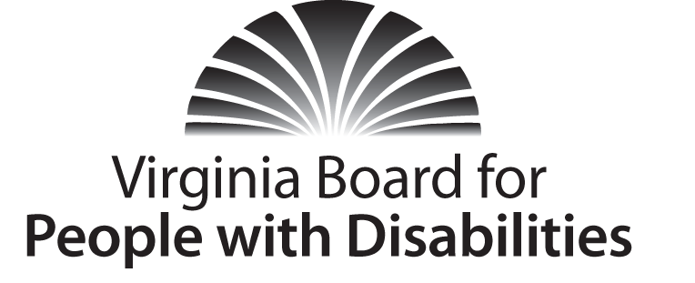
Mission
To create a Commonwealth that advances opportunities for independence, personal decision-making
and full participation in community life for individuals with developmental and other disabilities.

Vision
Virginians with developmental and other disabilities direct their own lives and
choose how they live, learn, work, and play.

BOARD MEETING AGENDA

Wednesday, September 9, 2014 − Four Points by Sheraton Hotel
4700 S. Laburnum Avenue, Richmond, VA 23231

5:30 pm DINNER
6:00pm Board Business Meeting Convenes – Ballrooms – Monet D & E
6:05 Call to Order, Charles Meacham
6:10 Approval of June 3, 2014 Board meeting minutes,
Action Required (Attachment BD 1), Charles Meacham
6:15 Executive Committee Report, Stephen Joseph
6:25 Public Comment
6:35 Action Items
VAIL Grant Renewal Application (Attachment EC 6), Charles Meacham
DARS Request for Conference Support (Attachment EC 7), Charles Meacham
YLF Ad hoc Committee recommendation (Attachment BD 2), Ed Turner
6:55 Board restructuring/Change Management, Charles Meacham
7:15 Other/New Business
7:30 Adjourn

