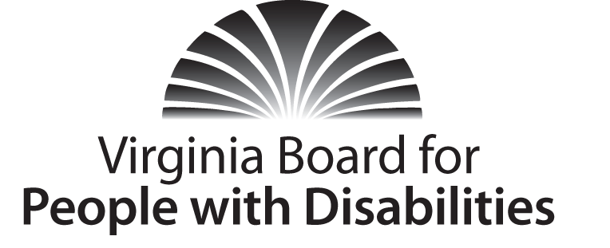
Mission
To create a Commonwealth that advances opportunities for independence, personal decision-making and full participation in community life for individuals with developmental and other disabilities.
Vision
Virginians with developmental and other disabilities direct their own lives and
choose how they live, learn, work, and play.

BOARD MEETING AGENDA

Wednesday, December 2, 2015 − Four Points by Sheraton Hotel
4700 S. Laburnum Avenue, Richmond, VA 23231

7:30am - 9:15 Executive Committee (see Attachment EC-1)

8:30 - 9:15 Coffee/Continental breakfast– Ballrooms - Monet D & E

9:25 FULL BOARD CONVENES
9:25 Welcome and Call to Order, Charles Meacham
9:30 Approval of September 9, 2015 Board meeting minutes, Action Required
(Attachment BD 1), Charles Meacham
9:35 Approval of June 2015 Committee Minutes, Action Required (Attachment BD 2)
9:40 Executive Committee Report, Stephen Joseph
9:50 Review of Consumer Satisfaction Survey Results, (Attachment BD 3), Ben
Jarvela
10:00 Discussion/Vote on revised Board Bylaws (Attachment BD 4), Charles Meacham
10:05 Discussion of FFY 2016 Competitive RFPs and other investments, Action Required (Supplemental Packet), Charles Meacham
10:30 Review of Draft Conference Support Guidelines, Action Required
(Attachment BD 5), Charles Meacham
10:40 Public Comment
10:45 Review and Discussion of FFY 2017-2021 State Plan Goals, Objectives, and draft activities (Attachment BD 6)
12:15 LUNCH
GRANT PRESENTATION: Pam Hinterlong, Instructor, Rehabilitation Research & Training Center, VCU; and Tonya Fowler, Executive Director, The Arc of Southside
1:20 Continued Work on State Plan Goals and Objectives
3:15 Committee Structure and Operations, Charles Meacham (Attachment BD 7)
3:45 Agency updates on policy, budget and programs, Agency designees
4:30 Other Business
4:35 Board Adjourns

