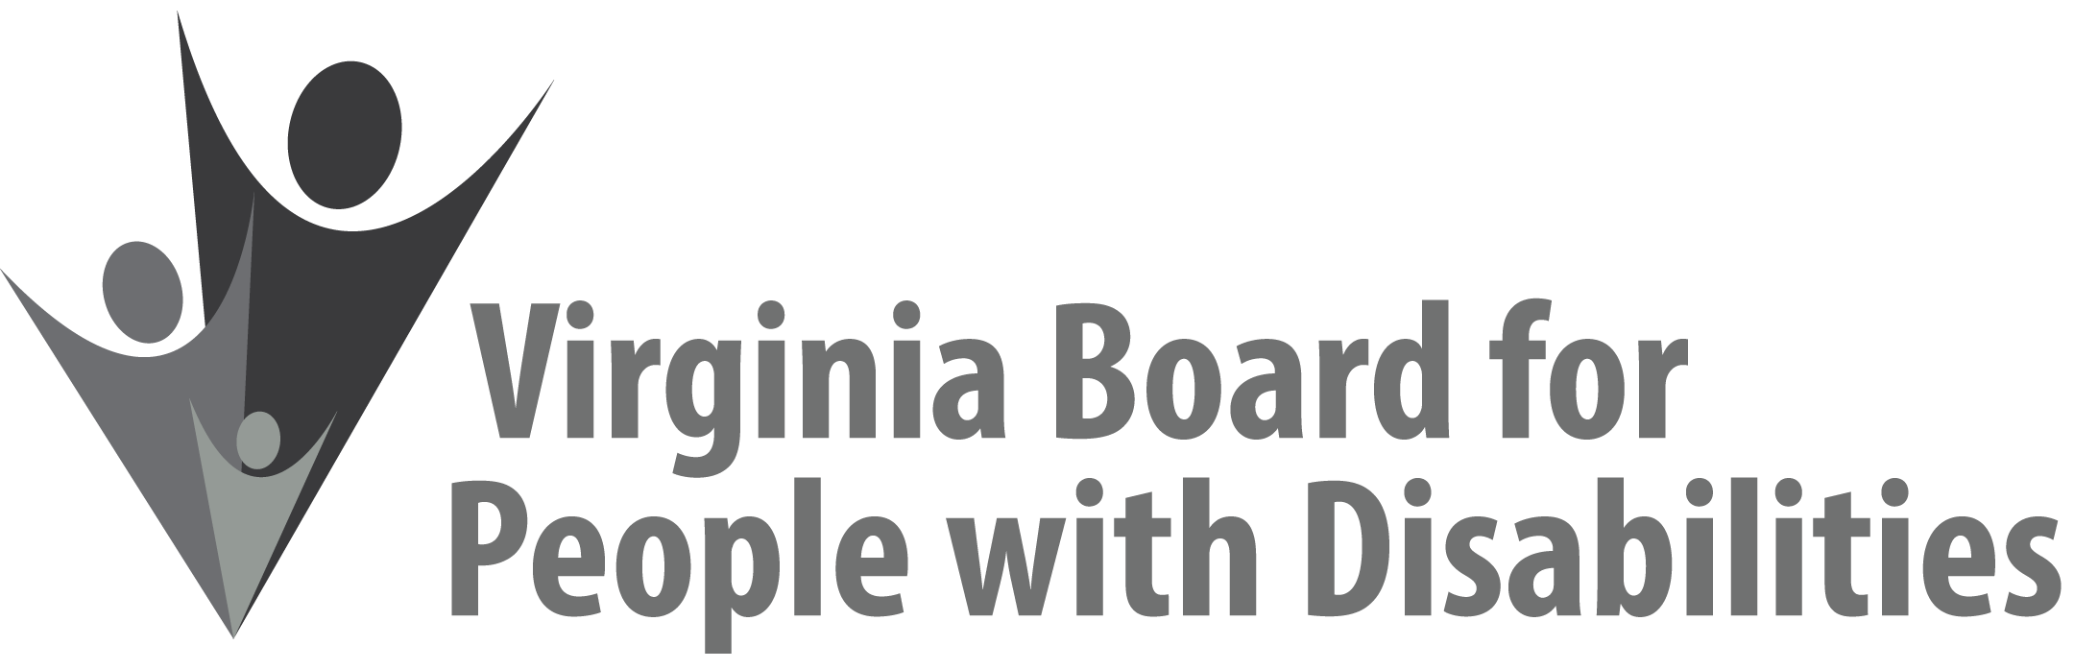

Mission
To create a Commonwealth that advances opportunities for independence, personal
decision-making and full participation in community life for individuals
with developmental and other disabilities.

Vision
Virginians with developmental and other disabilities direct their own lives
and choose how they live, learn, work, and play.

BOARD MEETING AGENDA

December 4, 2019
Four Points by Sheraton Hotel 4700 S. Laburnum Avenue
Richmond, VA 23231

8:00am - 9:05 am Executive Committee (Attachment EC 1)

8:30 - 9:00 Coffee/Continental breakfast– Ballrooms - Monet D & E

9:15– 11:15 COMMITTEE MEETINGS
Advocacy, Outreach, and Training, Renoir A
Investment and State Plan Oversight – Renoir B
Policy, Research, and Evaluation – Renoir C

11:30 Lunch – Ballrooms D & E
PRESENTATION: Update from the disAbility Law Center of Virginia, Colleen Miller, Esq., Executive Director

12:30 pm FULL BOARD CONVENES – Ballrooms D & E
12:35 Call to Order and Welcome, Ethel Parris Gainer, Chair
12:50 Approval September 11, 2019, Board meeting minutes, ACTION REQUIRED (Attachment BD 1), Ethel Parris Gainer, Chair
12:55 Public Comment
1:15 Report of the Grant Review Team, ACTION REQUIRED (Supplemental Packet), Alexus Smith
1:30 State Plan Update Approval, ACTION REQUIRED (Attachment BD 2)
1:40 Standing Committee Reports:
Report of the Advocacy and Outreach Committee
Committee name change, ACTION REQUIRED
(Attachment REF 1)
Report of the Policy, Research & Evaluation Committee
Committee name change, ACTION REQUIRED
(Attachment REF 1)
Report of the Investment & State Plan Oversight Committee
Committee name change, ACTION REQUIRED
(Attachment REF 1)
Approval of Event Sponsorship Request-CA Human Services, ACTION REQUIRED (Attachment BD 3)
Approval of Event Sponsorship Request-DSAGR, ACTION REQUIRED, (Attachment BD 4)
Questions on Executive Committee meeting
2:15 Agency and organizational updates
2:45 Other Business
Executive Director Recognition
3:45 Adjourn

