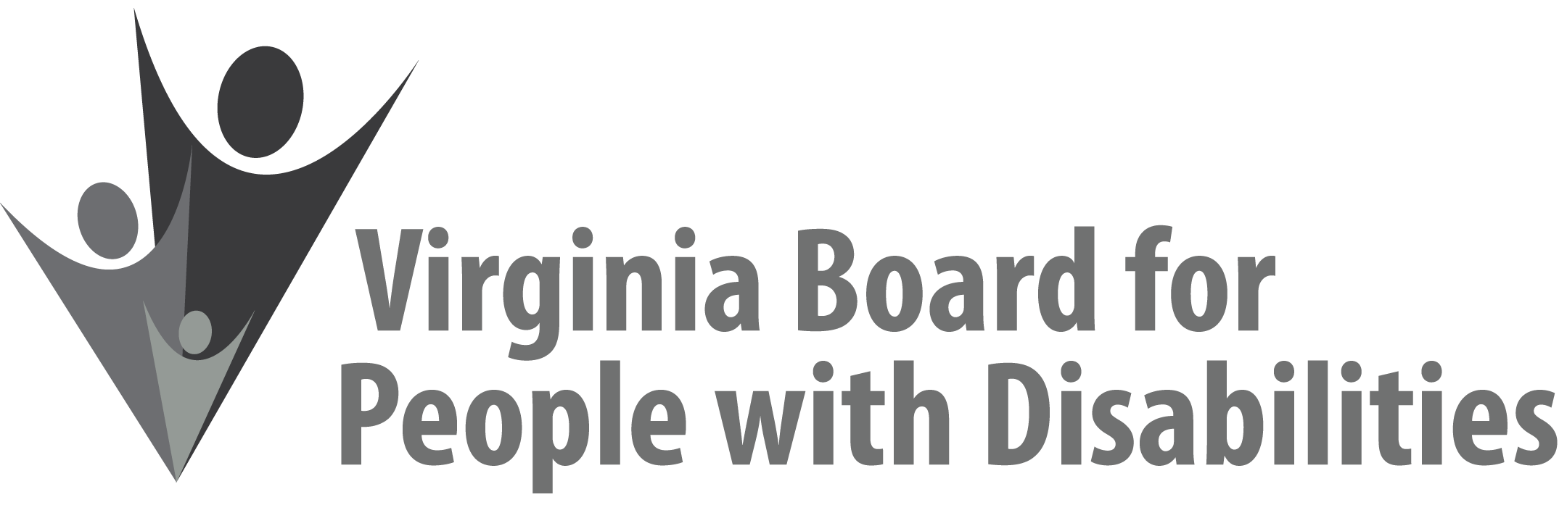

Mission
To create a Commonwealth that advances opportunities for independence, personal decision-making and full participation in community life for individuals with developmental and other disabilities.
Vision
Virginians with developmental and other disabilities direct their own lives and
choose how they live, learn, work, and play.
BOARD MEETING AGENDA

December 9, 2020 - Zoom Meeting

10:00am - 10:30am Executive Committee (Attachment EC 1)

10:35 – 11:30 COMMITTEE MEETINGS
Advocacy, Outreach, and Training – Zoom
Investment Committee – Zoom
Policy Advisory Committee – Zoom

11:30-12:00 BREAK

12:00 pm FULL BOARD CONVENES – Zoom Meeting
12:05 Welcome, Call to Order, Matthew Shapiro
12:30 Approval of September 16, 2020 Board meeting minutes, ACTION REQUIRED
(Attachment BD 1), Matthew Shapiro
12:35 Public Comment
12:40 Standing Committee Reports and Discussion:
Questions on Executive Committee meeting, Matthew Shapiro
Report of the Advocacy and Outreach Committee, Allison Coles-Johnson
Report of the Policy Advisory Committee, Phil Caldwell
Report of the Investment Committee, Alexus Smith
- Grantee no cost project extension due to COVID-19, Jason Withers
- VDDHH – 12 month extension to Jan. 2022 ACTION REQUIRED (Attachment BD 4),
- Radford University – 9 month extension to Sept. 2021 ACTION REQUIRED (Attachment BD 5)
      - Approval of Event Sponsorship Request-DSAGR, ACTION REQUIRED (Attachment BD 6), Jason Withers

1:10 FFY 2017-2021 State Plan Update Approval, ACTION REQUIRED
(Attachment BD 2), Nia Harrison
1:20 The DD Act Turns 50!, Teri Morgan
1:35 Review and Discussion of FFY 2022-2026 State Plan Goals, Objectives, and draft activities (Attachment BD 3), Dennis Findley
2:15 Other Business
2:30 Board Adjourns

