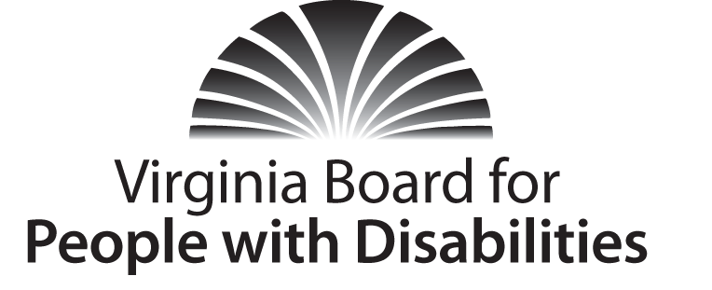

Mission
To create a Commonwealth that advances opportunities for independence, personal decision-making and full participation in community life for individuals with developmental and other disabilities.
Vision
Virginians with developmental and other disabilities direct their own lives and
choose how they live, learn, work, and play.

EXECUTIVE COMMITTEE MEETING
AGENDA

June 15, 2016 – Four Points by Sheraton Hotel
4700 S. Laburnum Avenue, Richmond, VA 23231

7:45 am - 9:00 am Renoir C
7:45 Call to Order and welcomes, Charles Meacham
7:48 Review of Executive Committee Meeting Agenda (Attachment EC 1),
Charles Meacham
7:52 Approval of Minutes of March 16, 2015 Executive Committee
Action required (Attachment EC 2), Charles Meacham
7:55 Board Member Attendance (Attachment EC 3), Stephen Joseph
7:58 Questions on Executive Director’s Update (Attachment EC 4), Heidi Lawyer
8:05 Questions on Agency Fiscal Report (Attachments EC 5), Nan Pemberton
8:10 Questions on Grant Expenditure Update (Attachment ISP 3), Jason Withers
8:15 FFY 2017 Grant Proposal update, (Supplemental Package) Jason Withers
8:20 SFY 2017 Agency Operating Budget, Nan Pemberton (Attachment EC 6) Action Required
8:35 Preparing for Potential Grant Investments for FFY 2018, Grace Lambert
8:45 Committee agendas, Committee Chairs/Staff
8:50 Other business
9:00 Adjourn

