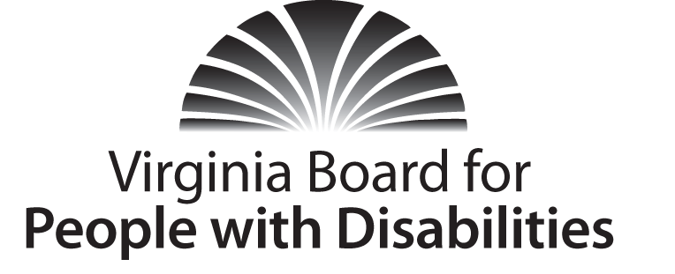

Mission
To create a Commonwealth that advances opportunities for independence, personal decision-making and full participation in community life for individuals with developmental and other disabilities.
Vision
Virginians with developmental and other disabilities direct their own lives and
choose how they live, learn, work, and play.

EXECUTIVE COMMITTEE MEETING

AGENDA

Wednesday, September 9, 2014 – Four Points by Sheraton Hotel
4700 S. Laburnum Avenue, Richmond, VA 23231

8:45– 10:30am Renoir C
8:45 Call to Order and welcomes, Charles Meacham
8:50 Review of Executive Committee Meeting Agenda (Attachment EC 1),
Charles Meacham
8:52 Approval of Minutes of June 3, 2015 Executive Committee
Action Required (Attachment EC 2), Charles Meacham
8:55 Board Member Attendance (Attachment EC 3), Stephen Joseph
9:00 Executive Director’s Update (Attachment EC 4), Heidi Lawyer
9:10 Agency Fiscal Report (Attachments EC 5), Nan Pemberton
9:15 FY’2015 End of Year Fiscal Report (Attachment EC 5-6), Nan Pemberton
9:20 Grant Expenditure Update (Attachment EC 5-5), Lynne Talley
9:25 VAIL Renewal Application, Action Required (Attachment EC 6), Lynne Talley
DARS Request for Conference Support, Action Required (Attachment EC 7),
Lynne Talley
9:35 Funds available for investment/RFPs, Lynne Talley
9:55 Review of Proposed Bylaws Changes (Attachment EC 8), Charles Meacham
10:00 Board restructuring/change management, Charles Meacham
10:30 Other Business/Adjourn

