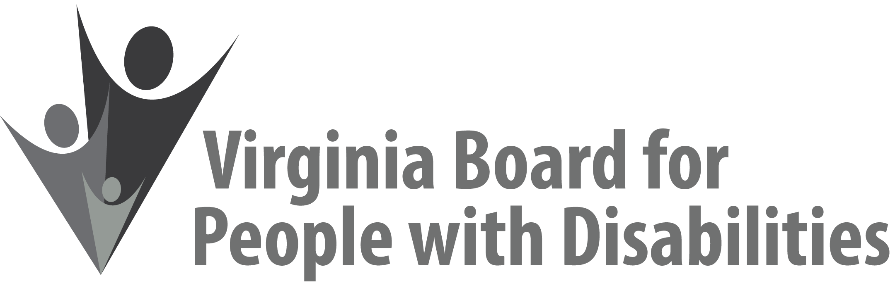

New Executive Committee Board Member Orientation & Meeting
July 25, 2019

Location: DARS Office for Aging Services - Division for Community Living
1610 Forest Avenue, Suite 100, Richmond, VA, 23229

10:00am – 11:15am Executive Committee (EC) Orientation (Benjamin Jarvela)

11:15am – 11:45am EC Meeting Facilitation and Discussion of The Standard Code of Parliamentary Procedure (John Cimino)

11:45am – 12:45pm Working Lunch

12:15pm – 1:45pm Discussion of EC Structure and Proposed Changes (Nia Harrison)

1:45pm – 2:15pm Committee Chair breakout sessions with agency staff

