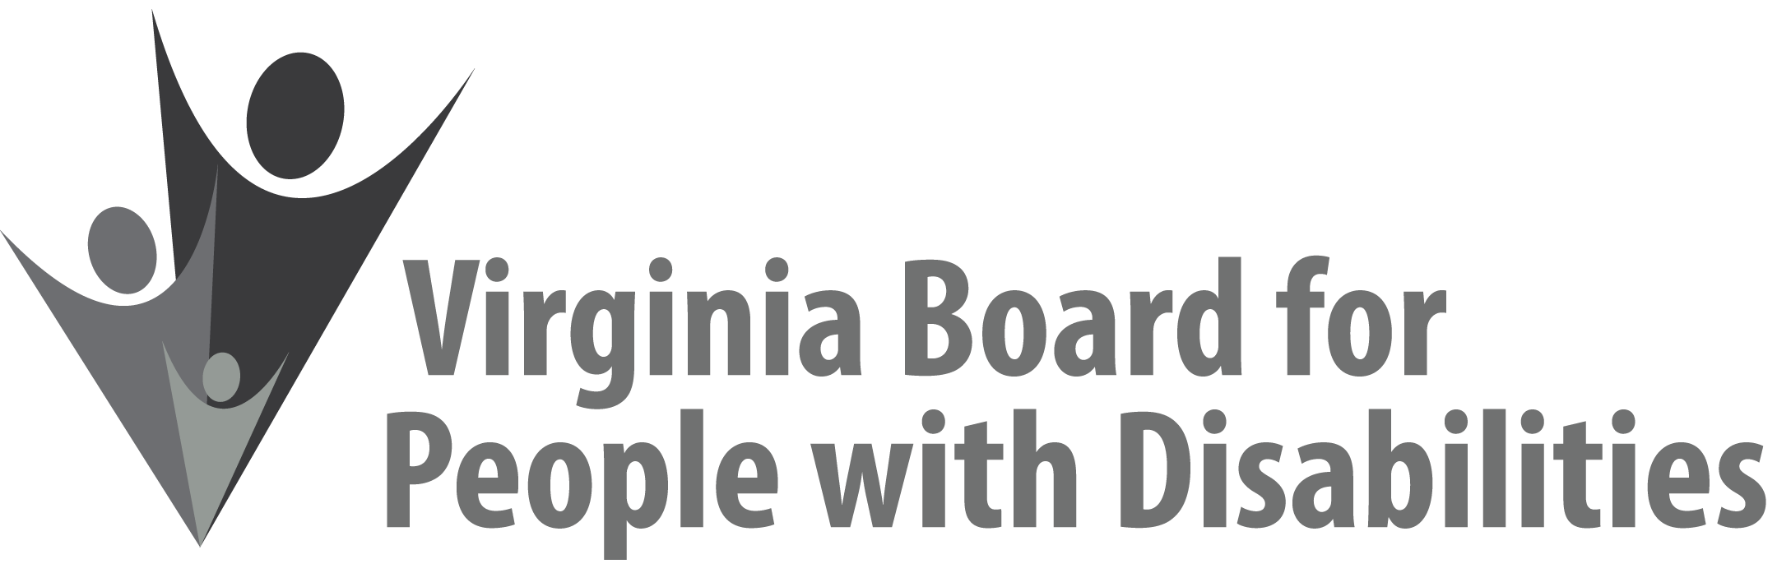

Mission
To create a Commonwealth that advances opportunities for independence, personal
decision-making and full participation in community life for individuals
with developmental and other disabilities.

Vision
Virginians with developmental and other disabilities direct their own lives
and choose how they live, learn, work, and play.

EXECUTIVE COMMITTEE AGENDA

July 31, 2020
12:00 pm - 12:45 pm
Zoom Meeting: https://zoom.us/j/92183765244
Zoom Call-In: +1 301 715 8592 | +1 312 626 6799 | +1 646 558 8656

12:00 Call to Order and welcomes, Ethel Parris Gainer
Notes:
- Review ground rules for telephonic meeting
- Introductions

12:05 Review of Purpose for the Executive Committee Meeting (Attachment EC 1),
Teri Morgan

12:10 Approval to Release new Request for Proposal (RFP) to Expend FFY 2018 Grant Funds by September 30, 2020, Executive Committee ACTION REQUIRED (Attachment EC 2), Teri Morgan & Jason Withers

12:45 Adjourn

