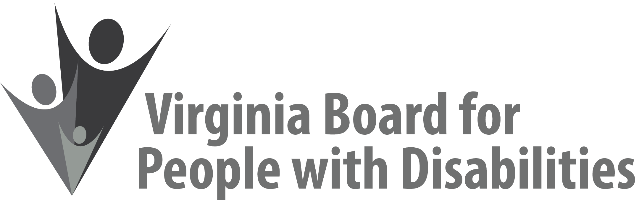

Mission
To create a Commonwealth that advances opportunities for independence, personal
decision-making and full participation in community life for individuals
with developmental and other disabilities.

Vision
Virginians with developmental and other disabilities direct their own lives
and choose how they live, learn, work, and play.

EXECUTIVE COMMITTEE AGENDA

June 10, 2020
11:00 am - 12:45 pm

11:00 Call to Order and welcomes, Ethel Parris Gainer
Notes:
- Review ground rules for telephonic meeting
- Introductions

11:10 Review of Executive Committee Meeting Agenda (Attachment EC 1),
Ethel Parris Gainer

11:15 Questions on Agency Fiscal Reports (Attachments EC 2), Henry Street

11:25 SFY 2021 Board Operational Budget, ACTION REQUIRED
(Supplemental Attachment), Henry Street

11:40 Update and reconsideration of FFY 2020 Grant Proposal Awards ACTION REQUIRED (Attachment EC 3), Jason Withers

11:45 Grant Renewal applications requiring Board approval, Jason Withers
- Arc of NOVA – Supported Decision-Making project ACTION REQUIRED (Attachment EC 4)
- Community Knights – COACH project ACTION REQUIRED
(Attachment EC 5)
- VCU – American Sign Language project ACTION REQUIRED
(Attachment EC 6)
12:05 Grantee no cost project extensions due to COVID-19, Jason Withers
              - Radford University – 3 month extension to Dec. 2020 ACTION REQUIRED (Attachment EC 7)
              - The Up Center – 3 month extension to Oct. 2020 ACTION REQUIRED (Attachment EC 8)
12:15 Executive Director’s Update and Questions (Attachment EC 9), Teri Morgan
- Nominations Committee status
- Board Appointments
- COVID-19 response

12:30 State Plan development process and update (Attachment EC 10), Nia Harrison

12:45 Public Comment

1:00 Other business and Adjourn

