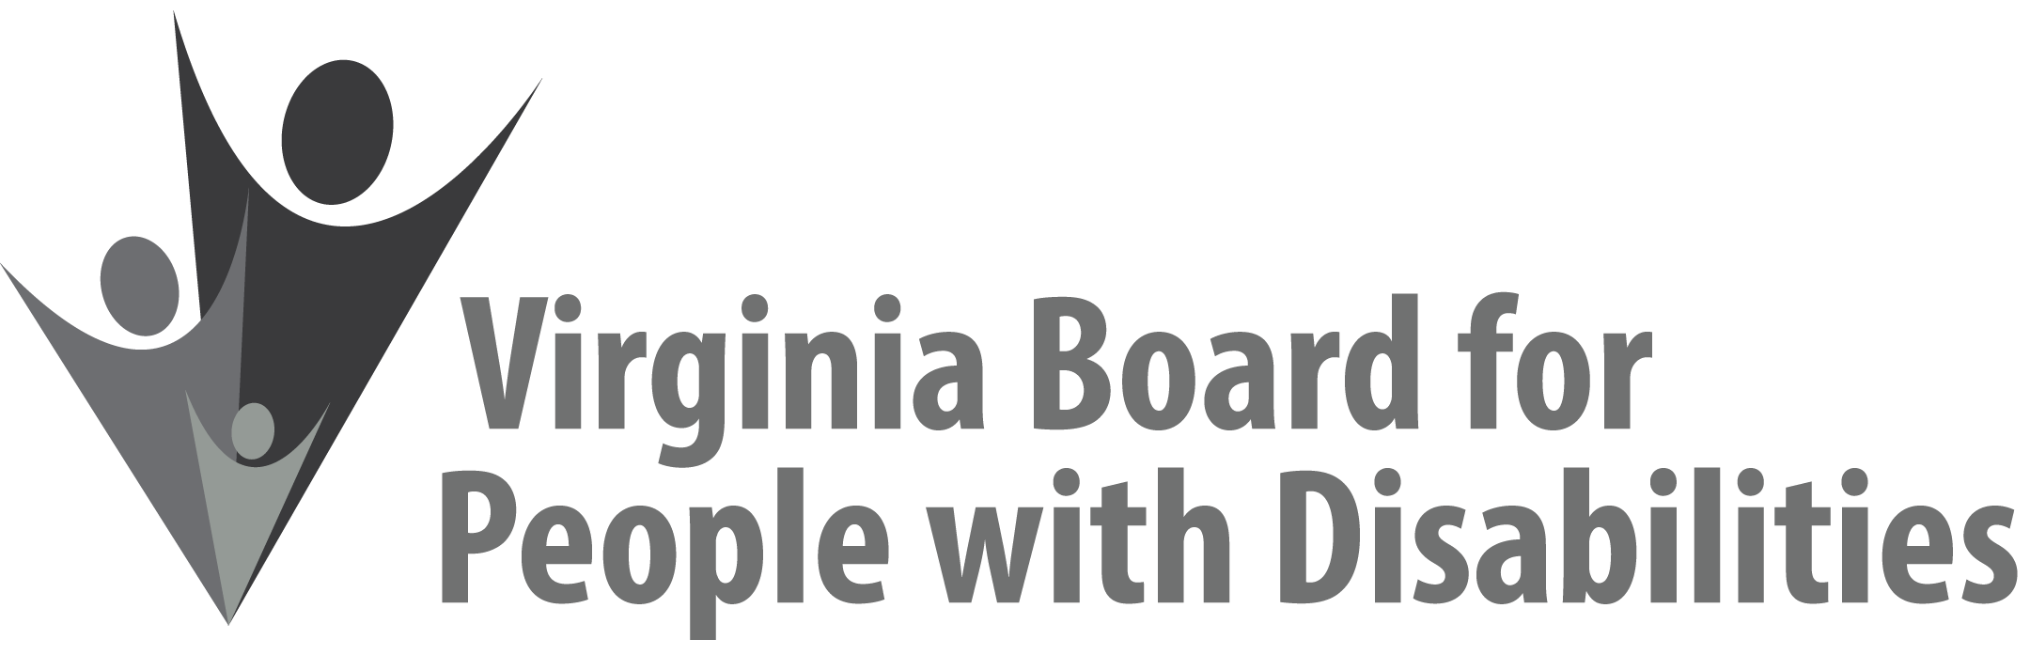

Mission
To create a Commonwealth that advances opportunities for independence, personal
decision-making and full participation in community life for individuals
with developmental and other disabilities.

Vision
Virginians with developmental and other disabilities direct their own lives
and choose how they live, learn, work, and play.

DRAFT BOARD MEETING AGENDA

June 12, 2019 - Four Points by Sheraton Hotel
4700 S. Laburnum Avenue, Richmond, VA 23231

7:45am - 9:05 am Executive Committee (see Attachment EC 1)

8:30 - 9:00 Coffee/Continental breakfast– Ballrooms - Monet D & E

9:15– 11:15 COMMITTEE MEETINGS
Advocacy, Outreach, and Training, Renoir A
Investment and State Plan Oversight – Renoir B
Policy, Research, and Evaluation – Renoir C

11:30 Lunch – Ballrooms D & E
Highlights of Alumni Development Program 3nd Year Evaluation, Nia Harrison, Penni Sweetenburg-Lee, (Attachment AOT 3)
12:15 Awards to Outgoing Board members, Mary McAdam

12:30 pm FULL BOARD CONVENES – Ballrooms D & E
12:35 Welcome, Call to Order, Mary McAdam
12:40 Approval March 13, 2019, Board meeting minutes, ACTION REQUIRED (Attachment BD 1), Mary McAdam
12:45 Public Comment
12:55 Report of the Nominations Committee and Vote on Slate of Officers, ACTION REQUIRED (Attachment BD 2), Chair of Nominations Committee
1:00 Presentation of SFY 2020 Board Operational Budget, ACTION
REQUIRED, (Attachment EC 6), John Cimino
1:15 PRESENTATION: CRITICAL DECISIONMAKING POINTS, Tracy Lee, Virginia Department of Education
2:00 Report of the Grant Review Team Committee on Competitive Proposals,
Theresa Casselman, ACTION REQUIRED (Supplemental Packet 1)
2:20. Standing Committee Reports:
Report of the Advocacy and Outreach Committee
Review of Event Sponsorship Policy, ACTION REQUIRED
(Attachment BD 3)
Review of Event Sponsorship Applications, ACTION REQUIRED
(Attachments BD 7 & BD 8)
Report of the Policy, Research & Evaluation Committee
Report of the Investment & State Plan Oversight Committee
Approval of William and Mary Scope of Work proposal, ACTION REQUIRED (Attachment BD 4)
Approval of JMU request to submit project continuation proposal, ACTION REQUIRED (Attachment BD 5)
Approval of VCU Project CHAT No-Cost Extension Request, ACTION REQUIRED (Attachment BD 6)
Approval to print Department of Education (DOE) curriculum guides, ACTION REQUIRED (Attachment BD 9)
Approval of concept paper received from the Department of Medical Assistance Services (DMAS), ACTION REQUIRED (Attachment BD 10)
Approval of Competitive RFPs, ACTION REQUIRED (Supplemental packet 2)

Questions on Executive Committee meeting
Committee Structure and Core Responsibilities (Attachment EC 7)
3:20 Agency and organizational updates
4:00 Other Business and Adjourn

