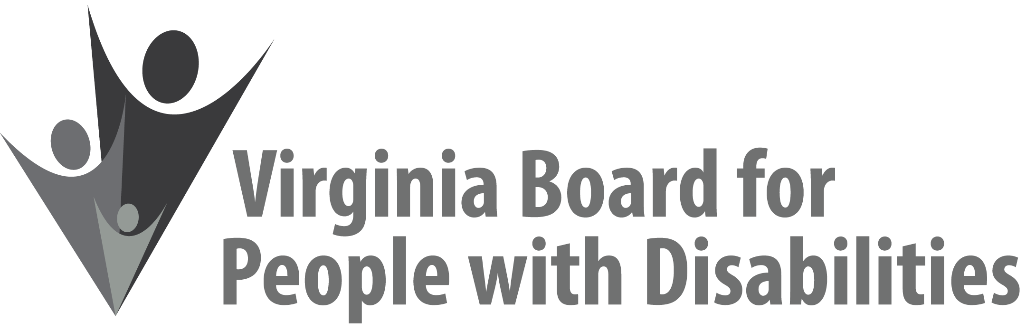

Mission
To create a Commonwealth that advances opportunities for independence, personal
decision-making and full participation in community life for individuals
with developmental and other disabilities.

Vision
Virginians with developmental and other disabilities direct their own lives
and choose how they live, learn, work, and play.

EXECUTIVE COMMITTEE AGENDA

June 12, 2019
7:45 am - 9:05 am Renoir C

7:45 Call to Order and welcomes, Mary McAdam
7:48 Review of Executive Committee Meeting Agenda (Attachment EC 1),
Mary McAdam
7:50 Approval of Minutes of March 13, 2019 Executive Committee
ACTION REQUIRED (Attachment EC 2), Mary McAdam
7:52 Board Member Attendance (Attachment EC 3), Jamie Snead
7:55 Questions on Executive Director’s Update (Attachment EC 4), Heidi Lawyer
8:05 Questions on Agency Fiscal Reports (Attachments EC 5), John Cimino
8:10 SFY 2020 Board Operational Budget, ACTION REQUIRED (Attachment EC 6), John Cimino
8:25 Questions on Grant Expenditure Update (Attachment ISP 4), Jason Withers
8:30 Update on FFY 2019 competitive grants, Jason Withers
8:35 Update on new Request for Proposals, Jason Withers (Supplemental Packet)
8:45 Discussion of Board committee structure and core responsibilities, (Attachment EC 7), ACTION REQUIRED, Nia Harrison
9:00 Committee agendas, Committee Chairs/Staff
9:05 Other business and Adjourn

