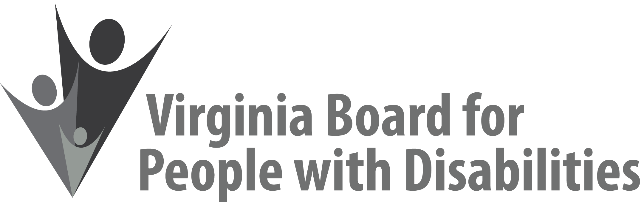

Mission
To create a Commonwealth that advances opportunities for independence, personal
decision-making and full participation in community life for individuals
with developmental and other disabilities.

Vision
Virginians with developmental and other disabilities direct their own lives
and choose how they live, learn, work, and play.

DRAFT BOARD MEETING AGENDA

June 13, 2018 - Four Points by Sheraton Hotel
4700 S. Laburnum Avenue, Richmond, VA 23231

7:45am - 9:00 am Executive Committee (see Attachment EC 1)

8:30 - 9:00 Coffee/Continental breakfast– Ballrooms - Monet D & E

9:15– 11:15 COMMITTEE MEETINGS
Advocacy, Outreach, and Training, Renoir A
Investment and State Plan Oversight – Renoir B
Policy, Research, and Evaluation – Renoir C

11:30 Lunch – Ballrooms D & E
Presentation: Virginia’s No Wrong Door Initiative, Sara Link, Director-No Wrong Door, Department for Aging and Rehabilitative Services
Recognition of Outgoing Board members

12:45pm FULL BOARD CONVENES – Ballrooms D & E
12:50 Welcome, Call to Order, Mary McAdam
12:55 Approval December March 14, 2018, Board meeting minutes, ACTION REQUIRED (Attachment BD 1), Mary McAdam
1:00 Public Comment
1:05 Report of the Nominations Committee and Vote on Slate of Officers, ACTION REQUIRED (Attachment BD 2), Chair of Nominations Committee
1:15 Presentation of SFY 2019 Board Operational Budget, ACTION
REQUIRED (SUPPLEMENTAL PACKET), Mary McAdam and John Cimino
1:45 Overview of Alumni Development Program 2nd Year Evaluation, Nia Harrison
(Attachment AOT 3)
2:10. Standing Committee Reports:
Questions on Executive Committee meeting
Report of the Advocacy and Outreach Committee
Report of the Policy, Research & Evaluation Committee, Summer Sage
Report of the Investment & State Plan Oversight Committee
Approval of Revised Event Support Procedures, ACTION
REQUIRED (Attachment BD 3)
2:45 Overview of Housing and Transportation Assessment Briefs, John Cimino
3:15 Agency and organizational updates
4:00 Other Business
4:15 Board Adjourns

