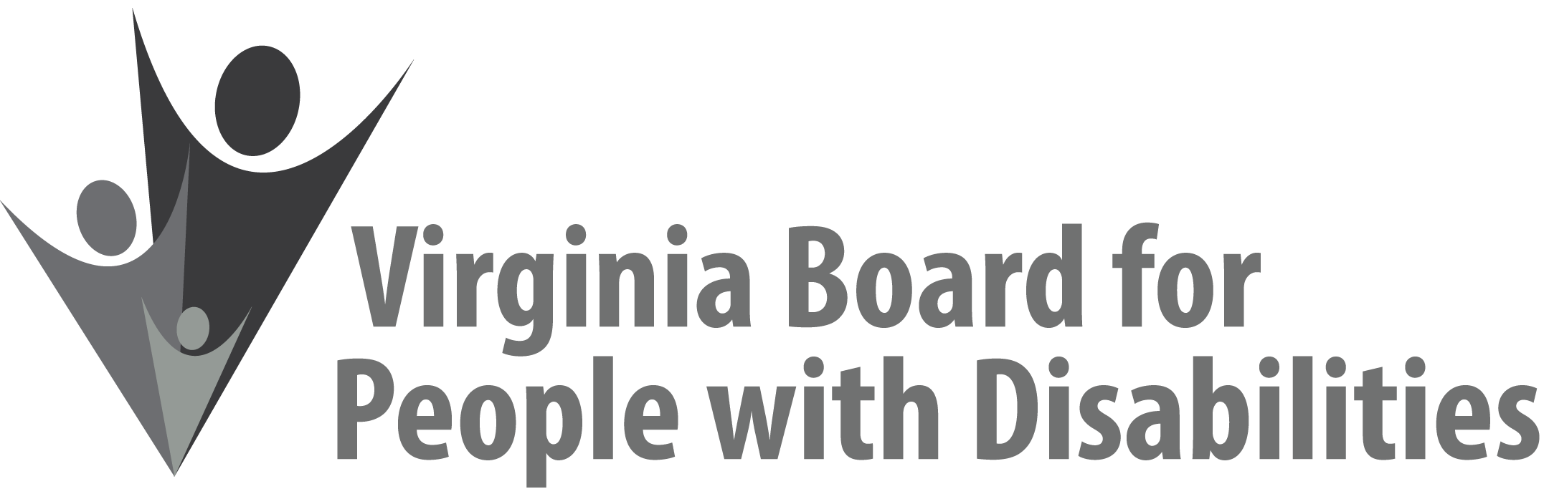
Mission
To create a Commonwealth that advances opportunities for independence, personal decision-making and full participation in community life for individuals with developmental and other disabilities.
Vision
Virginians with developmental and other disabilities direct their own lives and
choose how they live, learn, work, and play.

BOARD MEETING AGENDA

June 7, 2017 - Four Points by Sheraton Hotel
4700 S. Laburnum Avenue, Richmond, VA 23231

7:45am - 9:15 am Executive Committee (see Attachment EC 1)

8:30 - 9:00 Coffee/Continental breakfast– Ballrooms - Monet D & E

9:30– 11:30 COMMITTEE MEETINGS
Advocacy, Outreach, and Training, Renoir A
Investment and State Plan Oversight – Renoir B
Policy, Research, and Evaluation – Renoir C

11:45 Lunch – Ballrooms D & E
12:00 Presentation: Integrated Housing Options for People with Disabilities,
Sheree Hilliard, Community Options Specialist - Richmond Region 4, Community Operations-Housing, Department of Behavioral Health and
Developmental Services

Recognition of outgoing Board Members, Charles Meacham

1:15pm FULL BOARD CONVENES – Ballrooms D & E
1:20 Welcome, Call to Order, and Introductions, Charles Meacham
1:25 Approval of March 15, 2017 Board meeting minutes, ACTION REQUIRED
(Attachment BD 1), Charles Meacham
1:30 Report of the Nominations Committee and Vote on Slate of Officers (Attachment BD 2), Ron Lanier, ACTION REQUIRED
1:40 Public Comment
1:50 Standing Committee Reports:
Questions on Executive Committee meeting
Report of the Advocacy and Outreach Committee, Randy Burak
Report of the Policy, Research & Evaluation Committee, Summer Sage
Report of the Investment & State Plan Oversight Committee, Mary McAdam
Update on Letters of Interest, Grant Review Team Chair
2:10 Review and Approval of State Fiscal Year 2018 Budget, ACTION REQUIRED
(Attachment EC 6), Nan Pemberton
2:35 Agency and organizational updates
3:15 Other Business
3:30 Board Adjourns

