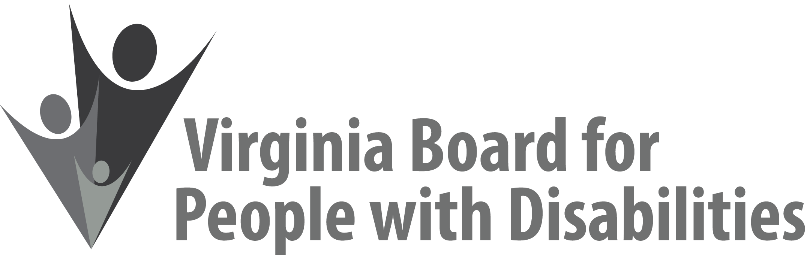

Mission
To create a Commonwealth that advances opportunities for independence, personal
decision-making and full participation in community life for individuals
with developmental and other disabilities.

Vision
Virginians with developmental and other disabilities direct their own lives and
choose how they live, learn, work, and play.

EXECUTIVE COMMITTEE MEETING AGENDA

June 7, 2017 – Four Points by Sheraton Hotel
4700 S. Laburnum Avenue, Richmond, VA 23231

7:45am - 9:15am Renoir C
7:45 Call to Order and welcomes, Charles Meacham
7:50 Review of Executive Committee Meeting Agenda (Attachment EC 1),
Charles Meacham
7:55 Approval of Minutes of March 15, 2017 Executive Committee meeting
ACTION REQUIRED (Attachment EC 2), Charles Meacham
7:58 Board Member Attendance (Attachment EC 3), Matthew Shapiro
8:00 Questions on Executive Director’s Update (Attachment EC 4), Heidi Lawyer
8:10 Alumni Development Program Update (Attachment AOT 3)
Penni Sweetenburg-Lee and Nia Harrison
8:25 Agency Fiscal Report (Attachments EC 5), Nan Pemberton
8:35 Grant Expenditure Update (Attachment ISP 3), Jason Withers
8:45 SFY 2018 Agency Operating Budget (Attachment EC 6), ACTION REQUIRED, Nan Pemberton
8:55 FFY 2018 LOI update, Jason Withers
9:05 Nominations Committee Update, (Attachment BD 2), Charles Meacham
9:10 Committee agendas, Committee Chairs
9:15 Other Business/Adjourn

