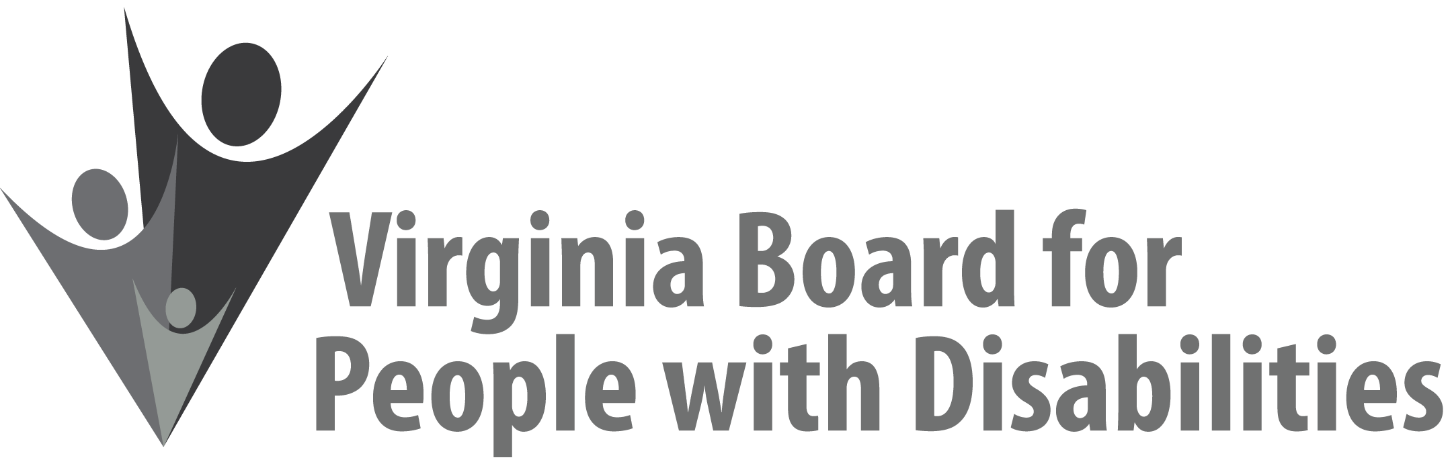

Mission
To create a Commonwealth that advances opportunities for independence, personal
decision-making and full participation in community life for individuals
with developmental and other disabilities.

Vision
Virginians with developmental and other disabilities direct their own lives
and choose how they live, learn, work, and play.

EXECUTIVE COMMITTEE AGENDA

June 9, 2021
9:45 am - 10:35 am Zoom Meeting

9:45 Call to Order and welcomes, Matthew Shapiro
9:50 Review of Executive Committee Meeting Agenda (Attachment EC 1),
Matthew Shapiro
9:55 Approval of March 10, 2021 Executive Committee Minutes
ACTION REQUIRED (Attachment EC 2), Matthew Shapiro
10:00 Board Member Attendance (Attachment EC 3), Alexandra Dixon
10:05 Questions on Executive Director’s Update (Attachment EC 4), Teri Morgan
10:10 Questions on Agency Fiscal Reports (Attachment EC 5), Henry Street
10:15 SFY 2022 Board Operational Budget, ACTION REQUIRED (Supplemental Packet), Henry Street
10:25 Update on FFY 2021 competitive grants & grant expenditures, Jason Withers
10:35 Other business & Adjourn

