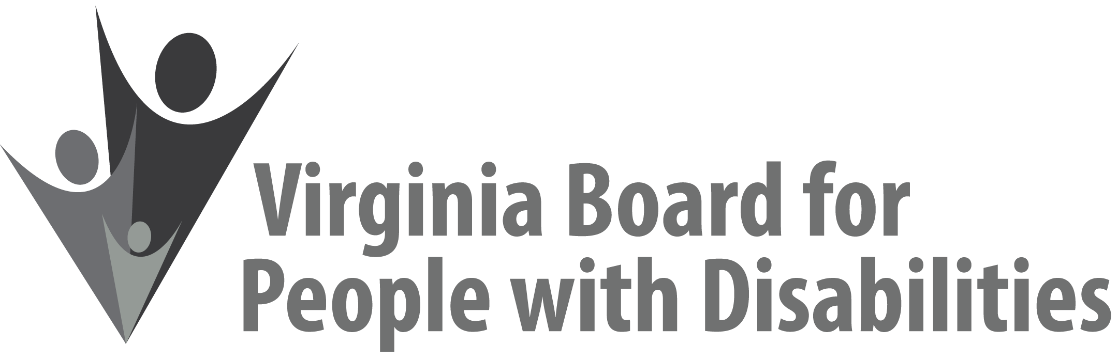

Mission
To create a Commonwealth that advances opportunities for independence, personal decision-making and full participation in community life for individuals with developmental and other disabilities.
Vision
Virginians with developmental and other disabilities direct their own lives and
choose how they live, learn, work, and play.
BOARD MEETING AGENDA

March 10, 2021 - Zoom Meeting

9:45am - 10:20am Executive Committee (Attachment EC 1)

10:30 – 12:15 COMMITTEE MEETINGS
Advocacy, Outreach, and Training – Zoom
Investment Committee – Zoom
Policy Advisory Committee – Zoom

12:15 -12:45 BREAK

12:45 pm FULL BOARD CONVENES – Zoom Meeting
12:50 Welcome, Call to Order, Matthew Shapiro
12:55 Approval of December 9, 2020 Board meeting minutes, ACTION REQUIRED
(Attachment BD 1), Matthew Shapiro
1:00 Public Comment
1:05 Appointment of Nominations Committee, Matthew Shapiro
1:15 Standing Committee Reports and Discussion:
Questions on Executive Committee meeting, Matthew Shapiro
Report of the Advocacy and Outreach Committee, Allison Coles-Johnson
Report of the Policy Advisory Committee, Phil Caldwell
Report of the Investment Committee, Alexus Smith
- Update on LOIs for Competitive RFPs
- Approval of Radford University Budget Amendment ACTION REQUIRED (Attachment BD 2)
- Update on the Virginia Department of Criminal Justice Services (DCJS) grant (Supplemental Packet)
- Approval to Develop and Release RFPs to Expend 2019 Award Funds by September 30, 2021 ACTION REQUIRED (Supplemental Packet)
- Approval to delegate award making authority to VBPD staff regarding 2019 award funds ACTION REQUIRED
1:40 Discussion of 2022-2026 State Plan public comment as relates to Plan, Action Required (Attachment BD 3)
1:50 Legislative Update, Clare Huerta
2:00 Other Business
2:30 Board Adjourns

