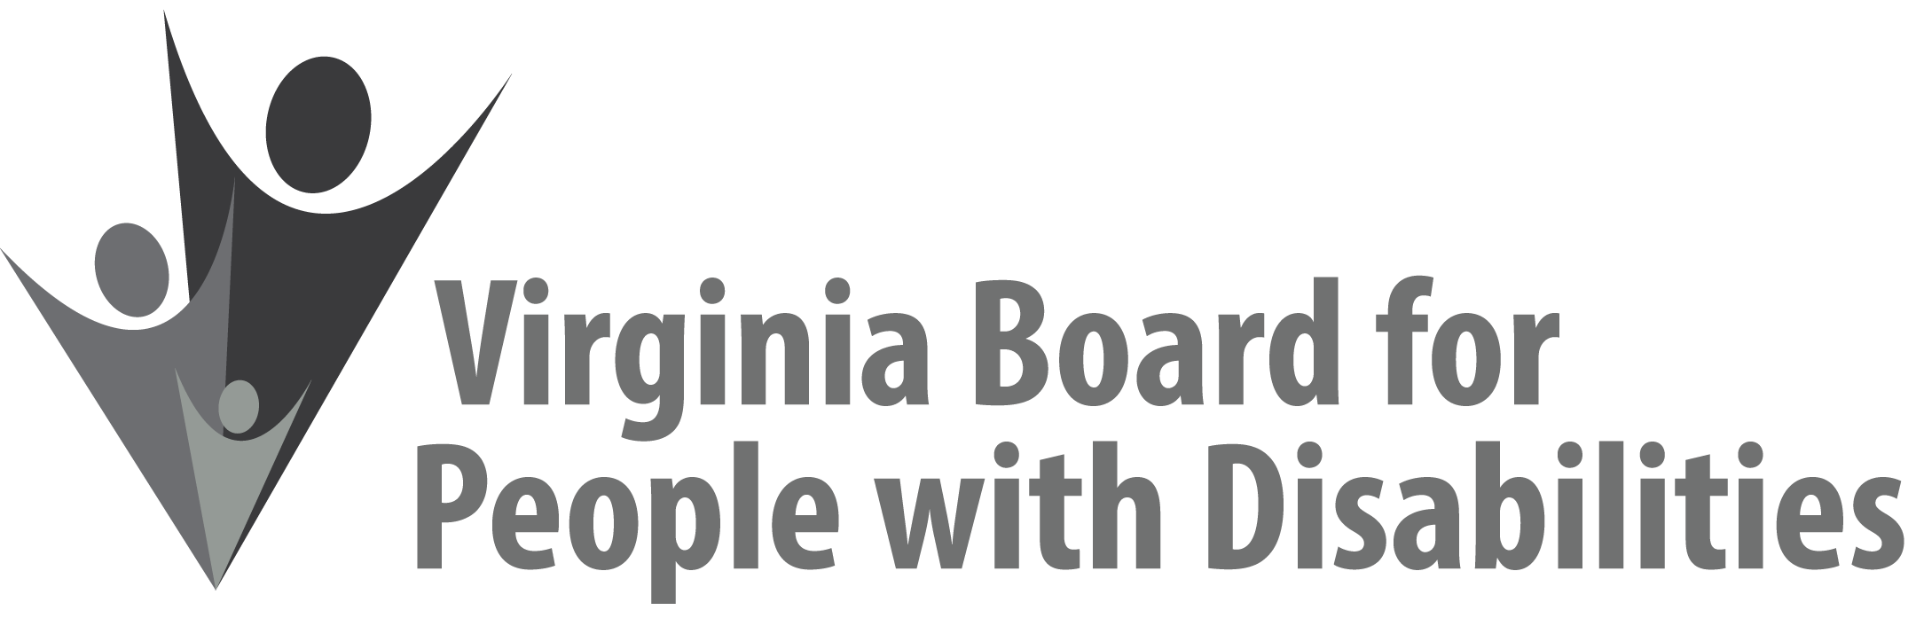

Mission
To create a Commonwealth that advances opportunities for independence, personal
decision-making and full participation in community life for individuals
with developmental and other disabilities.

Vision
Virginians with developmental and other disabilities direct their own lives
and choose how they live, learn, work, and play.

DRAFT BOARD MEETING AGENDA

March 13, 2019 - Four Points by Sheraton Hotel
4700 S. Laburnum Avenue, Richmond, VA 23231

7:45 - 9:00am Executive Committee (see Attachment EC 1)

8:30 - 9:00 Coffee/Continental breakfast– Ballrooms - Monet D & E

9:15– 11:30 COMMITTEE MEETINGS
Advocacy, Outreach, and Training, Renoir A
Investment and State Plan Oversight – Renoir B
Policy, Research, and Evaluation – Renoir C

11:45 Lunch – Ballrooms D & E
11:55 Presentation: Alumni Development Program Chapter Leadership

1:00 pm FULL BOARD CONVENES – Ballrooms D & E
1:05 Welcome, Call to Order, Mary McAdam
1:10 Approval December 5, 2018 Board meeting minutes, ACTION REQUIRED
(Attachment BD 1), Mary McAdam
1:15 Public Comment
1:25 Appointment of Nominations Committee, Mary McAdam
1:30 Legislative Update, John Cimino
1:40 Approval of Disability Assessment Recommendations, ACTION REQUIRED (Supplemental Packet), John Cimino
2:00 Standing Committee Reports:
Questions on Executive Committee meeting
Report of the Advocacy and Outreach Committee, Matthew Shapiro
Report of the Policy, Research & Evaluation Committee, Felicia Hamilton
Report of the Investment & State Plan Oversight Committee
Report from the Grant Review Team on Solicited Grant Proposal,
ACTION REQUIRED (Supplemental Packet 2)
2:30 PRESENTATION: dLCV Accessible Transportation Route Grant
Steve Traubert, Director of Litigation, dLCV
3:15 Agency and organizational updates
4:00 Other Business
4:05 Board Adjourns

