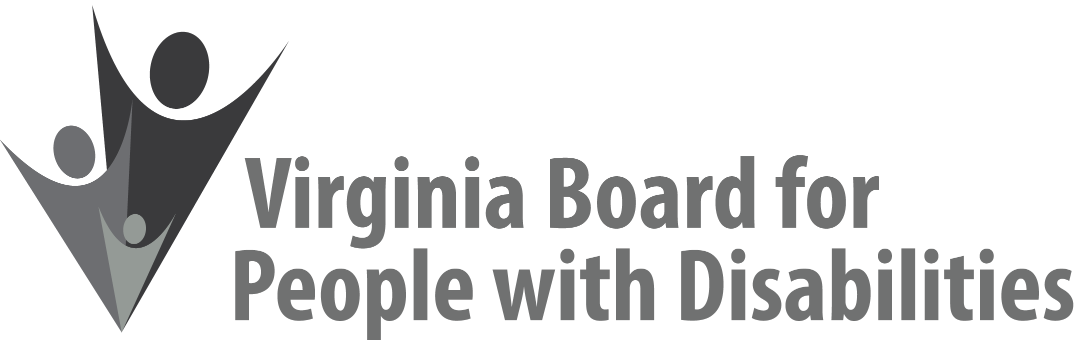
Mission
To create a Commonwealth that advances opportunities for independence, personal
decision-making and full participation in community life for individuals
with developmental and other disabilities.

Vision
Virginians with developmental and other disabilities direct their own lives
and choose how they live, learn, work, and play.

EXECUTIVE COMMITTEE AGENDA

March 13, 2019
7:45 am - 9:00 am Renoir C

7:45 Call to Order and welcomes, Mary McAdam
7:50 Review of Executive Committee Meeting Agenda (Attachment EC 1),
Mary McAdam
7:52 Approval of Minutes of December 5, 2018, Executive Committee
Action required (Attachment EC 2), Mary McAdam
7:55 Board Member Attendance (Attachment EC 3), Jamie Snead
7:58 Questions on Executive Director’s Update (Attachment EC 4), Heidi Lawyer
8:10 Board Vacancies (Attachment EC 5), Henry Street
8:15 Questions on Agency Fiscal Reports (Attachments EC 6), John Cimino
8:25 Questions on Grant Expenditure Update (Attachment ISP 4), Jason Withers
8:35 Update on Solicited Grant and Competitive RFP process for FFY 2019, Jason Withers
8:40 Board member survey results (Attachment EC 7), Nia Harrison
8:50 Committee agendas, Committee Chairs/Staff
8:55 Other business
9:00 Adjourn

