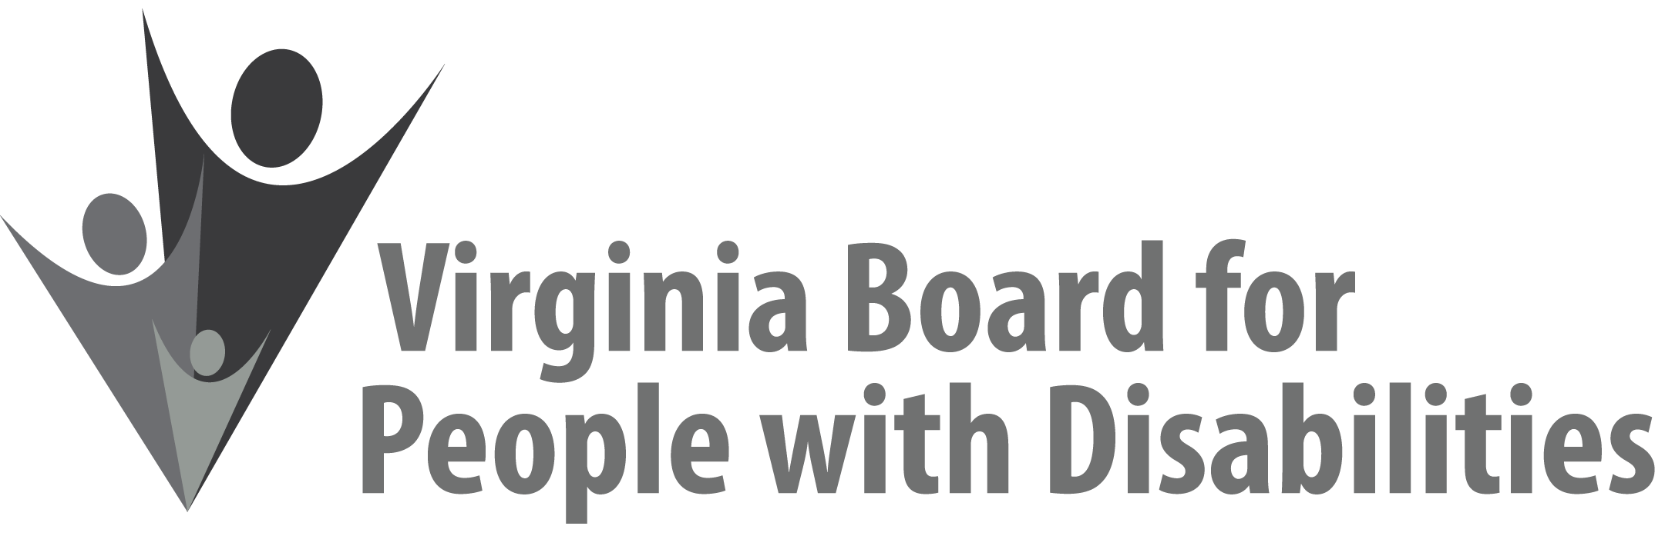

Mission
To create a Commonwealth that advances opportunities for independence, personal
decision-making and full participation in community life for individuals
with developmental and other disabilities.

Vision
Virginians with developmental and other disabilities direct their own lives
and choose how they live, learn, work, and play.

DRAFT BOARD MEETING AGENDA

March 14, 2018
Four Points by Sheraton Hotel
4700 S. Laburnum Avenue, Richmond, VA 23231

8:00am - 9:05am Executive Committee (see Attachment EC 1)

8:30 - 9:00 Coffee/Continental breakfast– Ballrooms - Monet D & E

9:15– 11:30 COMMITTEE MEETINGS
Advocacy, Outreach, and Training, Renoir A
Investment and State Plan Oversight – Renoir B
Policy, Research, and Evaluation – Renoir C

11:45 Lunch – Ballrooms D & E
12:00 PRESENTATION: Career Pathways for Students with Disabilities, Dr. Joe
Ashley, Department for Aging and Rehabilitative Services

1:00pm FULL BOARD CONVENES – Ballrooms D & E
1:00 Welcome, Call to Order, Mary McAdam
1:10 Approval December 6, 2017 Board meeting minutes, ACTION REQUIRED
(Attachment BD 1), Mary McAdam
1:15 Public Comment
1:20 Appointment of Nominations Committee, Mary McAdam
1:25 Alumni Development Program Leadership update
Chapter Co-Chairs
2:15 Legislative Update, John Cimino
2:30 Standing Committee Reports:
Questions on Executive Committee meeting
Report of the Advocacy and Outreach Committee
Approval of Revised Work plan, Alumni Development Program)
ACTION REQUIRED, (Attachment BD 2)
Approval of Event Support Applications 1 & 2
ACTION REQUIRED, (Attachment BD 5 & 6)
Report of the Policy, Research & Evaluation Committee, Summer Sage
Report of the Investment & State Plan Oversight Committee
Approval of VHREF No-Cost Extension Request, ACTION
REQUIRED, (Attachment BD 3)
Approval of Revised Event Support Procedures, ACTION
REQUIRED, (Attachment BD 4)
Approval of Competitive RFP, ACTION REQUIRED (Supplemental Packet)
3:00 Agency and organizational updates
4:00 Other Business
4:10 Board Adjourn

