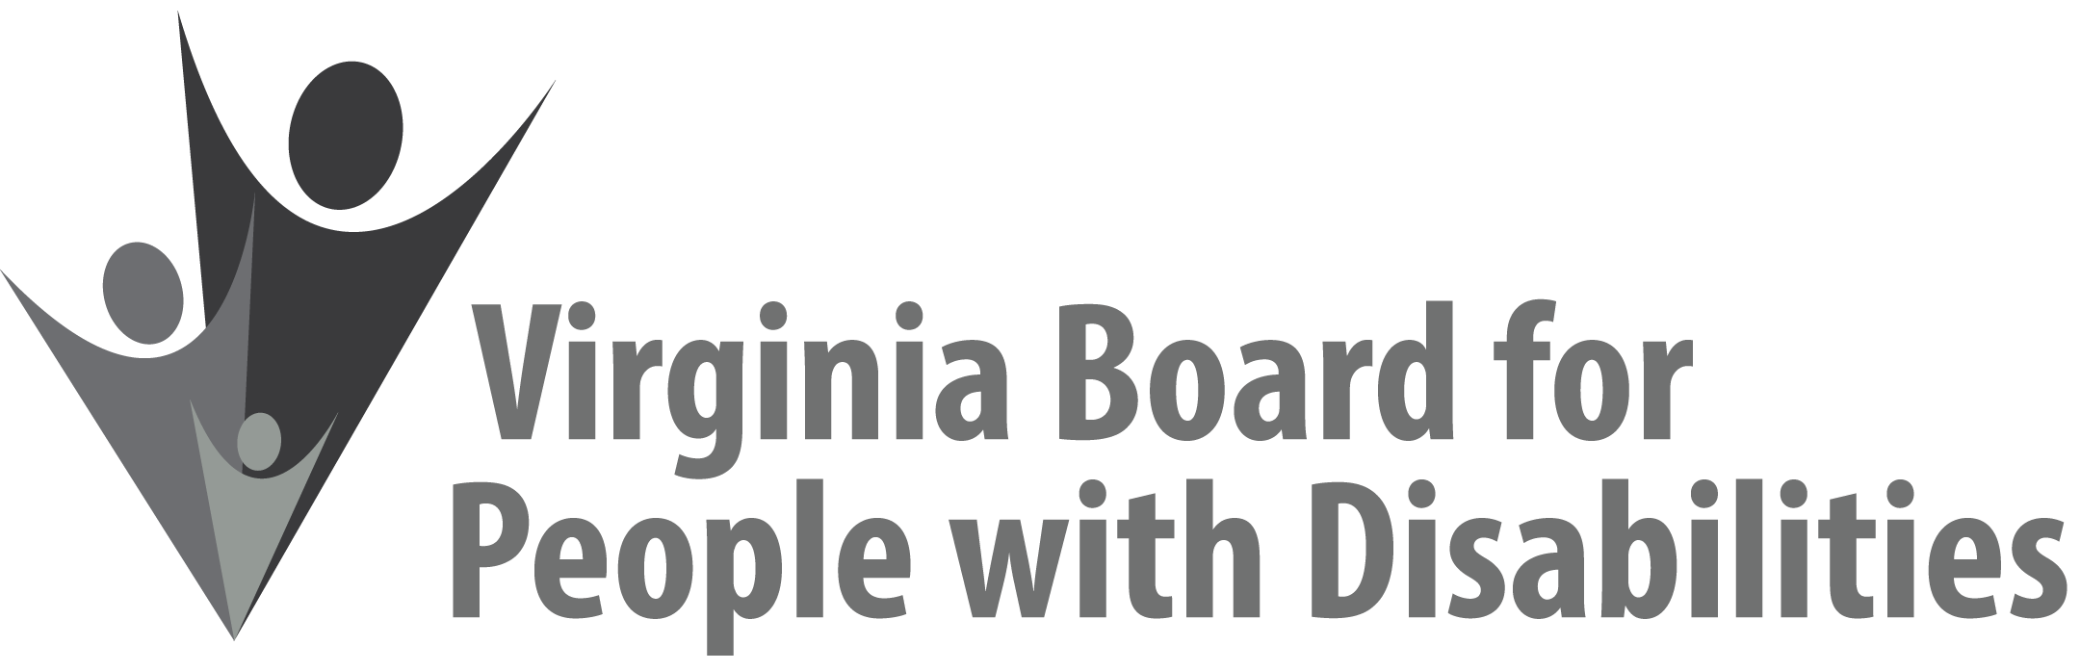

Mission
To create a Commonwealth that advances opportunities for independence, personal
Decision making and full participation in community life for individuals
with developmental and other disabilities.

Vision
Virginians with developmental and other disabilities direct their own lives
and choose how they live, learn, work, and play.

EXECUTIVE COMMITTEE AGENDA

March 11, 2020
8:00 am - 9:10 am Renoir C

8:00 Call to Order and welcomes, Ethel Parris Gainer
8:05 Remarks of new Executive Director, Teri Morgan
8:10 Review of Executive Committee Meeting Agenda (Attachment EC 1),
Ethel Parris Gainer
8:13 Approval of Minutes of December 4, 2019 Executive Committee Minutes,
ACTION REQUIRED (Attachment EC 2), Ethel Parris Gainer
8:15 Board Member Attendance (Attachment EC 3), Frederique Vincent
8:18 Questions on Executive Director’s Update (Attachment EC 4), Teri Morgan
8:25 Questions on Agency Fiscal Reports (Attachments EC 5), Henry Street
8:35 Questions on Grant Expenditure Update (Attachment ISP 3), Jason Withers
8:40 Update and reconsideration of FFY 2020 Grant Proposal Awards (Attachment EC 6), Jason Withers
8:50 State Plan Progress Report, (Attachment EC 7), Nia Harrison
9:00 Committee agendas, Committee Chairs/Staff
9:05 Other business
9:10 Adjourn

