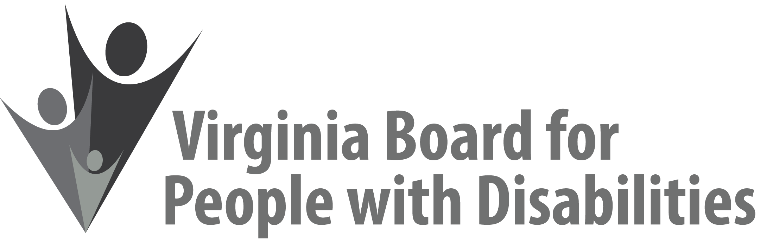

Mission
To create a Commonwealth that advances opportunities for independence, personal
decision-making and full participation in community life for individuals
with developmental and other disabilities.

Vision
Virginians with developmental and other disabilities direct their own lives
and choose how they live, learn, work, and play.

EXECUTIVE COMMITTEE AGENDA

September 11, 2019
8:00 am - 9:05 am Renoir C

8:00 Call to Order and welcomes, Ethel Parris Gainer
8:10 Review of Executive Committee Meeting Agenda (Attachment EC 1),
Ethel Parris Gainer
8:12 Approval of Minutes of June 12, 2019 Executive Committee Minutes,
ACTION REQUIRED (Attachment EC 2), Ethel Parris Gainer
Approval of Minutes of July 25, 2019 Executive Committee Minutes, ACTION REQUIRED (Attachment EC 2A), Ethel Parris Gainer
8:15 Board Member Attendance (Attachment EC 3), Frederique Vincent
8:20 Questions on Executive Director’s Update (Attachment EC 4), Heidi Lawyer
8:25 Questions on Agency Fiscal Reports (Attachments EC 5), John Cimino
8:35 Questions on Grant Expenditure Update (Attachment ISP 3), Jason Withers
8:45 Update on FFY 2020 competitive grant process/Letters of Interest, Jason Withers
8:50 Executive Committee recommendations on committee structure, Ethel Parris Gainer, Nia Harrison
9:00 Committee agendas, Committee Chairs/Staff
9:05 Other business and Adjourn

