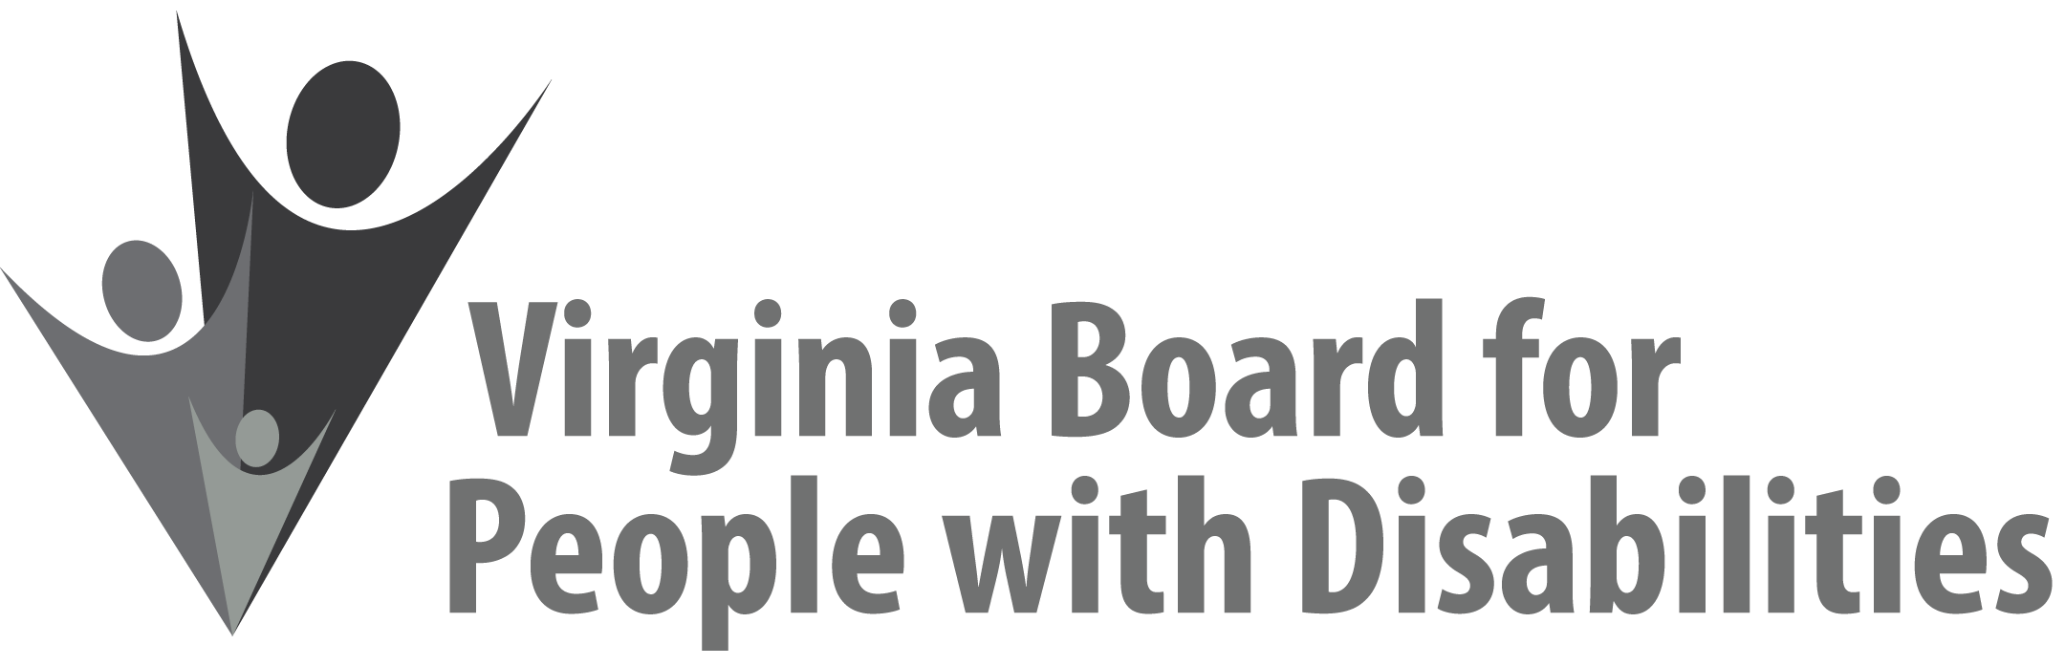

Mission
To create a Commonwealth that advances opportunities for independence, personal
decision-making and full participation in community life for individuals
with developmental and other disabilities.

Vision
Virginians with developmental and other disabilities direct their own lives
and choose how they live, learn, work, and play.

BOARD MEETING AGENDA

September 12, 2018 - Four Points by Sheraton Hotel, 4700 S. Laburnum Avenue, Richmond, VA 23231

8:00am - 9:00 am Executive Committee (see Attachment EC 1)

8:30 - 9:00 Coffee/Continental breakfast– Ballrooms - Monet D & E

9:15– 11:15 COMMITTEE MEETINGS
Advocacy, Outreach, and Training, Renoir A
Investment and State Plan Oversight – Renoir B
Policy, Research, and Evaluation – Renoir C

11:30 Lunch – Ballrooms D & E
Presentation: Partners in Policymaking and Youth Leadership Academy Graduates

12:45 pm FULL BOARD CONVENES – Ballrooms D & E
12:45 Welcome to New Board Members and Call to Order, Mary McAdam
1:00 Remarks from Secretary of Health and Human Resources, Daniel Carey, M.D.
1:30 Approval of June 13, 2018, Board meeting minutes, ACTION REQUIRED (Attachment BD 1), Mary McAdam
1:35 Public Comment
1:45. Standing Committee Reports:
Questions on Executive Committee meeting
Report of the Advocacy and Outreach Committee, Matthew Shapiro
Event Support Application ACTION REQUIRED (Attachment BD 2)
Report of the Policy, Research & Evaluation Committee, Felicia Hamilton
Report of the Investment & State Plan Oversight Committee, Theresa Casselman
Report from Grant Review Team--Approval of FFY 2019 Competitive Grants ACTION REQUIRED (Supplemental Packet)
Virginia Department of Education--Approval of Budget Amendment Request ACTION REQUIRED (Attachment BD 3)

2:45 Agency and organizational updates
3:35 Other Business
4:00 Board Adjourns

