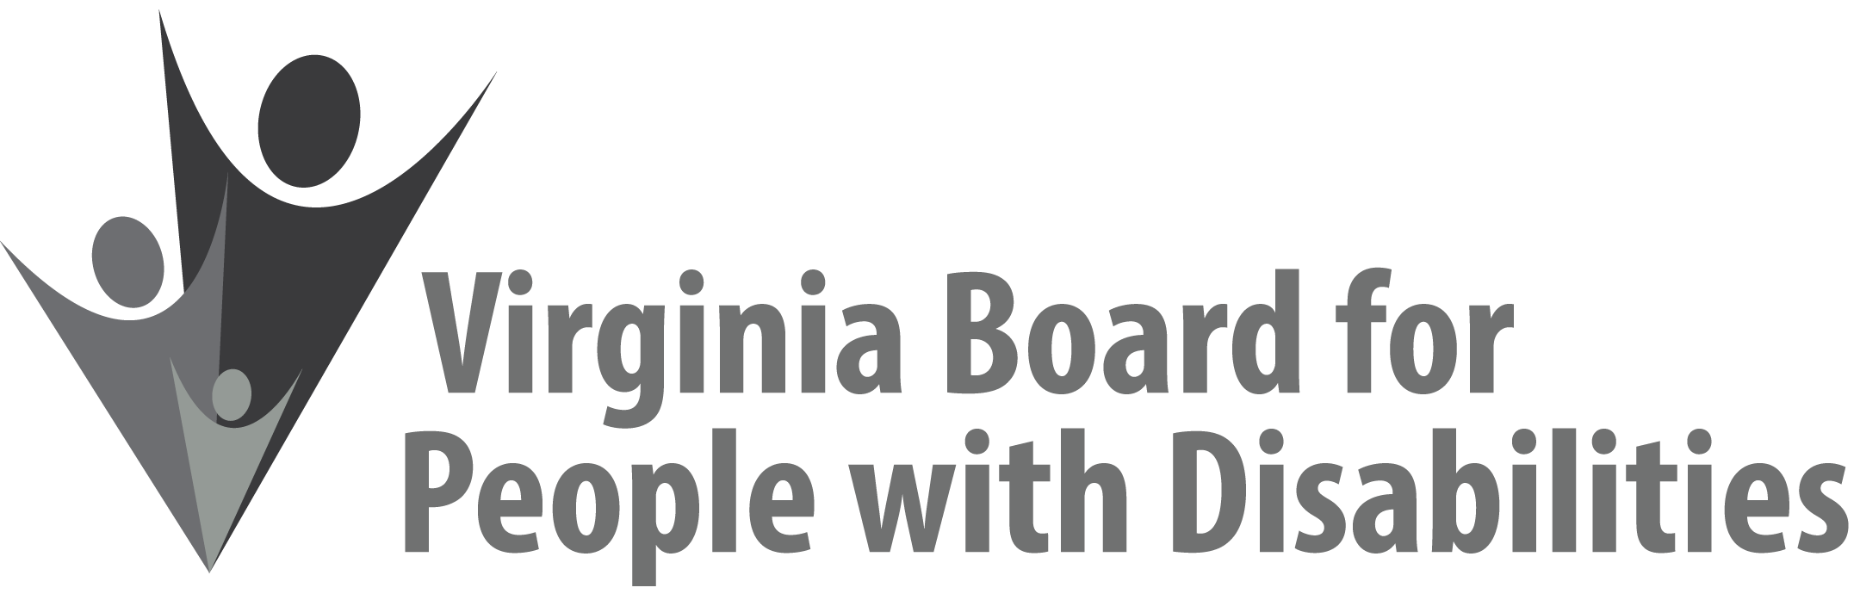

Mission
To create a Commonwealth that advances opportunities for independence, personal
decision-making and full participation in community life for individuals
with developmental and other disabilities.

Vision
Virginians with developmental and other disabilities direct their own lives
and choose how they live, learn, work, and play.

BOARD MEETING AGENDA

September 16, 2020 - Zoom Meeting

10:00am - 10:30 Executive Committee (see Attachment EC 1)

10:35–12:30 FULL BOARD CONVENES

10:35 Welcome, Call to Order, Welcome/Introduction of new Board members, Ethel Parris Gainer/Board Chair

10:50 Public Comment

10:55 Report of the Nominations Committee and Vote on Slate of Officers,
ACTION REQUIRED (Attachment BD 2), Chair of Nominations Committee

11:05 Board approval for 4 Assessments of Virginia’s Disability Service System in SFY 2021, ACTION REQUIRED (Attachment BD 3), Teri Morgan

11:20 Grantee no-cost project extension due to COVID-19, Jason Withers The Next Move @ William & Mary – 9 month extension to June 30, 2021 ACTION REQUIRED (Attachment BD 4)

11:30 Grantee no-cost project extension due to COVID-19, Jason Withers
The Up Center – SAFARI project – 3 month extension to Jan. 31, 2021
ACTION REQUIRED (Attachment BD 5)

11:40 Grantee no-cost project extension, Jason Withers
DCJS – School Crisis Planning Project – 12 month extension to Dec. 31, 2021, ACTION REQUIRED (Attachment BD 6)

11:50 Discussion and Approval of DRAFT FFY 2021 Competitive RFP, Jason Withers, ACTION REQUIRED (Supplemental Packet)

12:00 Discussion and Approval of DRAFT FFY 2020 RFP to support Technology for Students with Disabilities in Underserved Areas, Jason Withers, ACTION REQUIRED (Supplemental Packet)

12:10 5-Year State Plan Development: Process and Timeline Review, Nia Harrison

12:15 Board Discussion, Questions, Comments

12:30 Other Business and Adjourn

