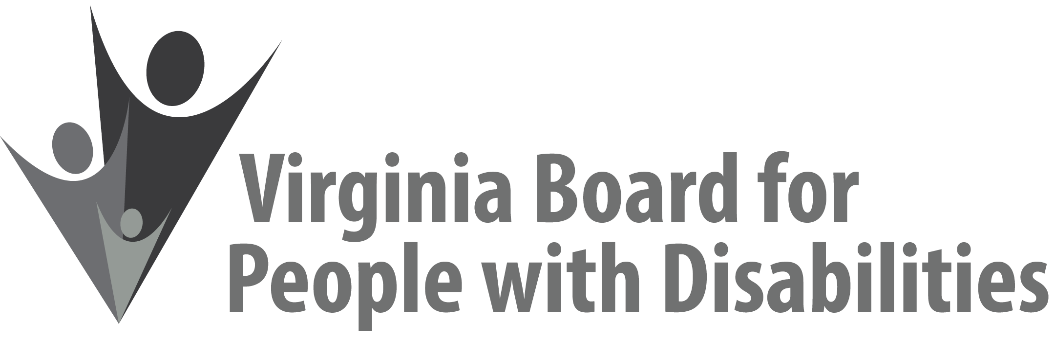

Mission
To create a Commonwealth that advances opportunities for independence, personal
decision-making and full participation in community life for individuals
with developmental and other disabilities.

Vision
Virginians with developmental and other disabilities direct their own lives
and choose how they live, learn, work, and play.

EXECUTIVE COMMITTEE AGENDA

September 16, 2020
10:00 am - 10:30 am Zoom Meeting

10:00 Call to Order and welcomes, Ethel Parris Gainer
10:05 Review of Executive Committee Meeting Agenda (Attachment EC 1),
Ethel Parris Gainer
10:10 Approval of June 10, 2020 Executive Committee Minutes
ACTION REQUIRED (Attachment EC 2), Ethel Parris Gainer
10:15 Board Member Attendance (Attachment EC 3), Frederique Vincent
10:20 Questions on Executive Director’s Update (Attachment EC 4), Teri Morgan
10:25 Questions on Agency Fiscal Reports (Attachments EC 5), Henry Street
10:30 Other business & Adjourn

