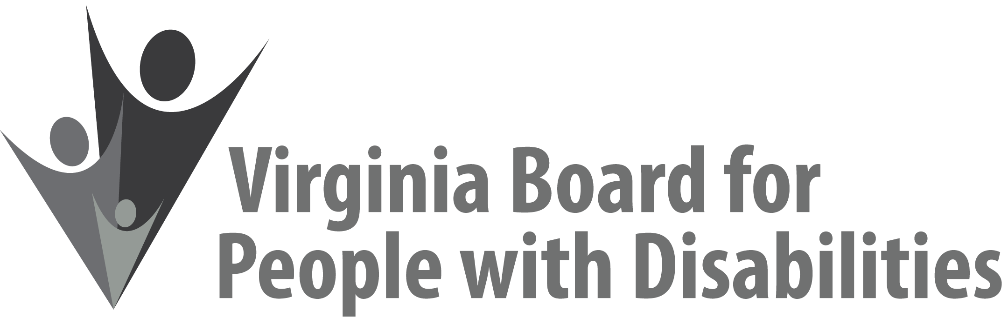

Mission
To create a Commonwealth that advances opportunities for independence, personal
decision-making and full participation in community life for individuals
with developmental and other disabilities.

Vision
Virginians with developmental and other disabilities direct their own lives
and choose how they live, learn, work, and play.

EXECUTIVE COMMITTEE AGENDA

September 15, 2021 – Shenandoah Junior Ballroom A

8:00 Call to Order and welcome, Alexus Smith
8:03 Review of Executive Committee Meeting Agenda (Attachment EC 1),
Alexus Smith
8:05 Approval of June 9, 2021 Executive Committee Minutes
ACTION REQUIRED (Attachment EC 2), Alexus Smith
8:10 Board Member Attendance (Attachment EC 3), Sarah Kranz-Ciment
8:15 Questions on Executive Director’s Update (Attachment EC 4), Teri Morgan
8:25 Questions on Agency Fiscal Reports (Attachment EC 5), Henry Street
8:35 Committee agendas, Committee Chairs/Staff
8:45 Other business & Adjourn

