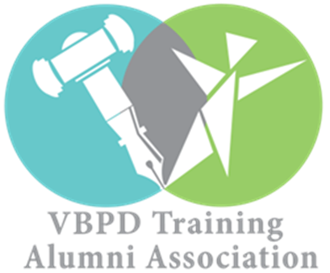

CVA REGIONAL ALUMNI CHAPTER CALENDAR OF EVENTS

OCTOBER

DATE: Saturday, October 7, 2017
CHAPTER MEETING
TIME: 11:00 AM – 1:00 PM
LOCATION: Reynolds Community College
1651 E Parham Rd.
Richmond, VA 23228
Barnette Hall Room 257
Complimentary Lunch Provided

DATE: Saturday, October 14, 2017
LOCAL ADVOCACY EVENT– DSAGR’s “Step Up for Down Syndrome” 5K Fundraiser
TIME: 8:30 AM
LOCATION: ACCA Shrine Center
1712 Bellevue Avenue
Richmond, VA 23227

JANUARY

DATE: Wednesday, January 10, 2018
CHAPTER MEETING
TIME: 6-8 PM
LOCATION: TBA, likely in Mechanicsville
Complimentary Refreshments Provided

DATE: Wednesday, January 17, 2018
STATE ADVOCACY EVENT-DD ADVOCACY DAY
TIME: To Be Determined
LOCATION: Richmond State Capitol
1000 Bank St
Richmond, VA 23218
*Free transportation provided & logistical information to be announced*
Complimentary Lunch Provided

MARCH

DATE: Saturday, March 10, 2018
PIP SESSION 6 CVA RECRUITMENT SYMPOSIUM
TIME: 1:30 pm – 3:30 pm
LOCATION: Holiday Inn Hotel
4303 Commerce Rd
Richmond, VA 23234

DATE: Wednesday, March, 14, 2018
QUARTERLY BOARD MEETING CVA LEADERSHIP
TIME: 10:00 am – 1:00 pm
LOCATION: Sheraton Four Points Hotel
4700 South Laburnum Avenue
Richmond, VA, 23231

DATE: Saturday, March 24, 2018
ADVOCACY EVENT – Arc South of the James Resource Fair (Self-advocate Richard Cuevas speaking at 11)
TIME: 10:00 am – 1:00 pm
LOCATION: Colonial Heights High School
3600 Conduit Road
Colonial Heights, VA 23834

APRIL

DATE: Wednesday, April 4, 2018
CHAPTER MEETING
TIME: 6-8 PM
LOCATION: TBA, Charlottesville Region
Complimentary Refreshments Provided

DATE: Wednesday, April 18, 2018
NATIONAL ADVOCACY EVENT “Hear Our Voices”
TIME: To Be Determined
LOCATION: Washington D.C.
*Free transportation & logistical information to be announced*
Complimentary Lunch Provided
JUNE

DATE: Saturday, June 2, 2018
CHAPTER MEETING
TIME: 10 AM – 2 PM
LOCATION: Science Museum of Virginia
2500 W Broad St.
Richmond, VA 23220
Complimentary Lunch Provided

COLLABORATIVE DISABILITY ADVOCACY ORGANIZATIONS

1. The Arc of Virginia
2. The Autism Society of Central Virginia
3. Down Syndrome Association of Greater Richmond
4. Cerebral Palsy of Virginia
5. Canine Companions for Independence

AT A GLANCE CALENDAR OF EVENTS LOCATIONS

Richmond
Mechanicsville
Charlottesville
Colonial Heights

OVERVIEW OF CVA CHAPTER ALUMNI ADVOCACY ACTIVITES

4 Chapter Meetings
2 Local Events
1 State Event
1 National Event

