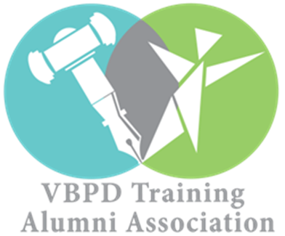

NoVA REGIONAL ALUMNI CHAPTER CALENDAR OF EVENTS

OCTOBER

DATE: Tuesday, October 3, 2017
CHAPTER MEETING & WAIVER CHANGE INFORMATIONAL
TIME: 6:00-8:30 PM
LOCATION: Arc of Greater Prince William
13505 Hillendale Drive
Woodbridge, VA 22193

NOVEMBER

DATE: Tuesday, November 21, 2017
LOCAL ADVOCACY: Prince William County Board of County Supervisors Meeting
TIME: 7:30 PM
LOCATION: Prince William County McCoart Administration Building
Board Chambers, 1 County Complex
Woodbridge, VA 22193

DECEMBER

DATE: Saturday, December 2, 2017
CHAPTER MEETING
LOCATION: To Be Announced
TIME: 10:00AM-12:00PM
Complimentary Lunch Provided

JANUARY

DATE: Monday, January 15, 2018
CHAPTER MEETING
TIME: 9:00AM-10:00AM
LOCATION: Uptown Alley Manassas Mall
8300 Sudley Rd
Manassas, VA 20109
Community Room

DATE: Wednesday, January 17, 2018
STATE ADVOCACY EVENT: DD Advocacy Day
TIME: To Be Determined
LOCATION: Richmond State Capitol
1000 Bank St
Richmond, VA 23218

FEBRUARY
DATE: Monday, February 19, 2018
Leadership Conference Call
TIME: 8:00 am

MARCH

DATE: Thursday, March 22, 2018
LOCAL ADVOCACY EVENT: Board of County Supervisors Meeting
TIME: 7PM
LOCATION: TBA

DATE: Saturday, March 10, 2018
PIP SESSION 6 CVA RECRUITMENT SYMPOSIUM
TIME: 1:30 pm – 3:30 pm
LOCATION: Holiday Inn Hotel
4303 Commerce Rd
Richmond, VA 23234

DATE: Wednesday, March, 14, 2018
QUARTERLY BOARD MEETING CVA LEADERSHIP
TIME: 10:00 am – 1:00 pm
LOCATION: Sheraton Four Points Hotel
4700 South Laburnum Avenue
Richmond, VA, 23231

DATE: Wednesday, April 18, 2018
NATIONAL ADVOCACY EVENT “Hear Our Voices”
TIME: To Be Determined
LOCATION: Washington D.C.
*Free transportation & logistical information to be announced*
Complimentary Lunch Provided

MAY

DATE: Saturday, Tentatively Scheduled for May 5th or May 19th 2018
CHAPTER MEETING AND ALUMNI OUTREACH & RECRUITMENT EVENT
TIME: TBD
LOCATION: Wheatland Farms
15158 Berlin Turnpike
Purcellville, VA 20132

