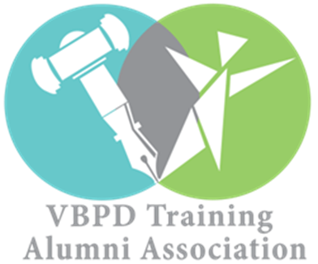

SWA REGIONAL ALUMNI CHAPTER CALENDAR OF EVENTS

OCTOBER
DATE: Saturday, October 21, 2017
CHAPTER MEETING
TIME: 10:00 AM – 12:00 PM
LOCATION: Hollins University Campus
7916 Williamson Rd
Roanoke, VA 24019
Complimentary Lunch Provided

DECEMBER
DATE: Saturday, December 2, 2017
CHAPTER MEETING
TIME: 12:00-2:00PM
LOCATION: Radford University
801 E Main St
Radford, VA 24141
Room Location: To Be Announced
Complimentary Lunch Provided

JANUARY

DATE: Wednesday, January 17, 2018
STATE ADVOCACY EVENT- DD ADVOCACY DAY
LOCATION: Richmond State Capitol
1000 Bank St
Richmond, VA 23218
TIME: To Be Determined
*Free transportation & logistical information to be announced*
Complimentary Lunch Provided

MARCH

DATE: Saturday, March 10, 2018
PIP Session 6 SWA RECRUITMENT SYMPOSIUM
TIME: 1:30 pm – 3:30 pm
LOCATION: Holiday Inn Hotel
4303 Commerce Rd
Richmond, VA 23234

DATE: Wednesday, March, 14, 2018
QUARTERLY BOARD MEETING SWA LEADERSHIP
TIME: 10:00 am – 1:00 pm
LOCATION: Sheraton Four Points Hotel
4700 South Laburnum Avenue
Richmond, VA, 23231

APRIL

DATE: Saturday, April 7, 2018
CHAPTER MEETING
TIME: 12:00 PM – 2:00 PM
TENTATIVE LOCATIONS: Virginia Tech University, Blacksburg
or Blacksburg Library, Blacksburg
Complimentary Lunch Provided

DATE: Tuesday, April 10, 2018
LOCAL ADVOCACY EVENT
TIME: 4:00 PM - 6:00 PM
LOCATION: Montgomery County Public Schools Transition Fair
Christiansburg High School
100 Independence Blvd.
Christiansburg, VA 24073

DATE: Wednesday, April 18, 2018
NATIONAL ADVOCACY EVENT “Hear Our Voices”
TIME: To Be Determined
LOCATION: Washington D.C.
*Free transportation & logistical information to be announced*
Complimentary Lunch Provided

MAY

DATE: Saturday, May 19, 2018
CHAPTER MEETING
TIME: 12:00 PM – 2:00 PM
TENTATIVE LOCATIONS: Central Virginia Community College, Lynchburg or Jones Memorial Library, Lynchburg
Complimentary Lunch Provided

DATE: Saturday, May 19, 2018
ALUMNI OUTREACH & RECRUITMENT EVENT
TIME: 2:30 PM – 5:00 PM
LOCATION: Amazement Square
27 9th St
Lynchburg, VA 24504

COLLABORATIVE DISABILITY ADVOCACY ORGANIZATIONS

1. The Arc of Virginia (New River Valley & Roanoke Valley)
2. Moms in Motion
3. Special Olympics
4. Special Families Support Group (Roanoke) & Families of Autism Community Enrichment Services (FACES)
5. Parent Educational Advocacy Training Center (PEATC)
6. Special Education Advisory Committee (SEAC) Montgomery County
7. Blue Ridge Independent Living Center (BRILC)-Roanoke
8. Department of Blind and Vision Impaired (DBVI)-Roanoke
9. Special Needs Trust Symposium by Ms. Ann Green, Attorney

AT A GLANCE CALENDAR OF EVENTS LOCATIONS
Roanoke
Radford
Blacksburg
Lynchburg

OVERVIEW OF SWA CHAPTER ALUMNI ADVOCACY ACTIVITES

4 Chapter Meetings
2 Local Events
1 State Event
1 National Event

