COVID-19 Relief Related Service Units

For agencies with access to Families First Coronavirus Response Act (FFCRA), COVID-19 Coronavirus Aid Relief and Economic Security (CARES) Act and / or the Major Disaster Declaration as a result of the COVID-19 relief effort. Within this document, these three relief efforts will have abbreviated names of Families First, CARES Act and Disaster Declaration.

April 20, 2020

New Service Types for CARES Act and Families First
To assist you with utilizing the CARES Act and Families First aid, new Service Types have been setup for your agency in the programs where you normally track Home Delivered Meals, Congregate Meals, Transportation as well as in your CRIA2 program.

These new Service Types were setup for tracking services supported by the CARES Act and Families First. The Service Types setup in your traditional meals and transportation programs are named:
CARES Act Home Delivered Meals
CARES Act Congregate Meals
CARES Act Transportation
Families First Home Delivered Meals
Families First Congregate Meals

You will need to establish new Event Profiles for these new Service Types and add the individuals receiving meals under the CARES Act and / or Families First to those new Events and enter units into those new Events the same way you already do for your existing meals services each month. New Events are needed because only one service type can be used for a single Event Profile. Additionally, new Events are needed because changing the service type of an existing Event will change the service type on that Event for every service unit ever entered into that Event which would not work for this process.

When creating the new Events and entering units, please select the funding sources of Families First for Families First service type units and CARES Act for CARES Act service type units. For additional information on how to enroll individuals, setup new Events and add people to those Events, see the help guide provided on PeerPlace under Support / NWD Documents / NWD Enrollment and Service Unit Entry.

If you would like for the new Families First Home Delivered Meals and / or the CARES Act Home Delivered Meals new service types to be additionally set up in your Congregate Meals program(s), please contact the helpdesk at NWDHelp@dars.virginia.gov to discuss that request as it may save you some time with the enrollment process from having to move people from your congregate program(s) to your home delivered program(s). However, it may also have undesirable impacts on program level reporting depending on how your agency utilizes certain reports. The help desk can assist you with this decision.

These new Families First and CARES Act service types have also been established in your CRIA2 program along with other services under the CARES Act that can be tracked using the CRIA2 Units Entry screen. For additional information on how to track units in CRIA2, see the help guide provided on PeerPlace under Support / NWD Documents / NWD CRIA2 Service Units Entry. These services have been setup in your CRIA2 program to allow for an expedited method of units entry without the need for program enrollment. However, you would need to do a separate CRIA2 Encounter for each individual. If you would like for these service types to be set up in additional programs for ease of use, please contact the help desk at NWDHelp@dars.virginia.gov.
The following services types below are available now in CRIA2 and are named:
CARES Act Emergency
CARES Act Checking
CARES Act Care Coordination
CARES Act CG Other Supplemental
CARES Act CG Other Respite
CARES Act Transportation
CARES Act Home Delivered Meals
CARES Act Congregate Meals
CARES Act Asst Transportation
CARES Act Care Transitions
CARES Act CDSME
CARES Act CG Individual Counseling
CARES Act CG Support Groups
CARES Act Chore
CARES Act CRIA
CARES Act Disease Prevention
CARES Act Employment
CARES Act Homemaker
CARES Act Options Counseling
CARES Act Personal Care
CARES Act Socialization Recreation
CARES Act Volunteer
Families First Home Delivered Meals
Families First Congregate Meals

Regardless of where the units for these new services types are tracked, the units and individuals served will not show up on the ‘AAA Service Summary’ (or ‘AAA Service Summary Sub-Contractors’ for those with linked sub-contractors) reports. This is because they are to be kept separated from your standard units counts per the guidance received with the funds distribution. For that reason, use the ‘Service Units and Summary Report’ and run the report for ‘All Programs’ and use the same date span as you would for the ‘AAA Service Summary’ report. Once the report has completed, download it and look at the ‘State Service Type’ tab. Locate the rows matching the services named above and use the columns named ‘Client Served (Unduplicated)’ and ‘Units’ for your AMR reporting.

These numbers are to be entered on the newly revised AMR OC in the corresponding location for the service.

Questions regarding PeerPlace usage for this process are to be directed to the helpdesk at NWDHelp@dars.virginia.gov.

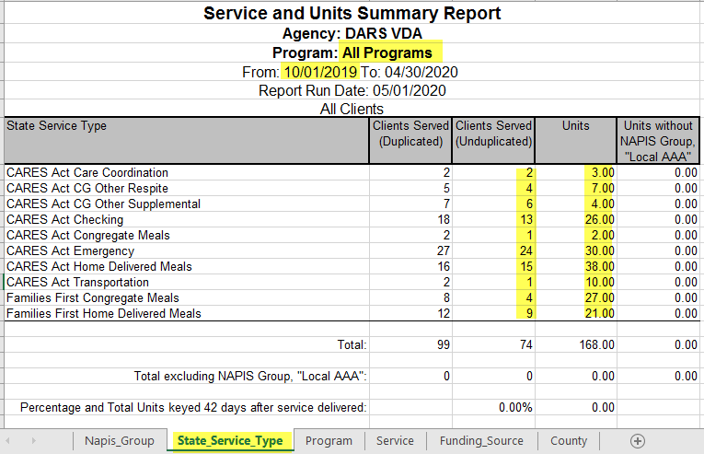

New Service Types and Funding Source for Disaster Declaration

1. Each AAA has been provided with a new funding source named 'COVID-19' and it is to be used when tracking all service units on the system for Disaster Declaration. Do not use this funding source for Families First and / or CARES Act services. This funding source is intended to be used with your pre-existing traditional service types as a way to identify which of all units entered are open to the additional funding sources allowed under the Disaster Declaration.

2. New Checking and Emergency service types have been added to your existing meals programs and are to be used for Disaster Declaration units tracking within those specific programs. These service types were added in the meals programs because not all agencies had these services within the existing area plans and the need to track these services for meals recipients was needed. If you need these service types added to additional programs for ease of use, Please contact the help desk at NWDHelp@dars.virginia.gov. When using these new service types, please select the new service type below along with the funding source of ‘COVID-19’.
The services types are named:
Checking COVID-19
Emergency COVID-19

3. A revision to the existing report named Service and Units Summary is coming soon that will include a new tab to show a breakdown by service type alongside the funding source and this should be used to identify the new COVID-19 funding source units and individuals served for the AMR for Disaster Declaration. This report change is still being developed but is projected to be available for the May 12th AMR submission for April units.

4. The units tracked will also fall onto the AAA Service Summary report for your AMR tracking as they are not required to be separated out in the same way as CARES Act and Families First. An additional tab on the AMR will be dedicated to Disaster Declaration units which are identified by the funding source of ‘COVID-19’.

SAMPLE of revised report still in development:

