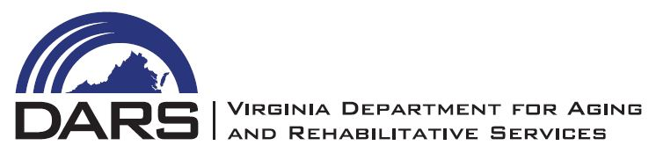
AUDIT REPORT EXTENSION REQUEST FORM

Please accept this letter as our request to extend the submission date of the area agency’s audit report for FY ________ from December 15th to _______________.

As stipulated in our area agency contract with DARS, our agency has contracted with an accounting firm or independent Certified Public Accountant to perform the annual audit. An engagement letter was secured on _____________________ and the expected completion date for the audit report is ________________________________.

Comments/Reasons for request:
__________________________________________________________________
__________________________________________________________________
__________________________________________________________________

____________________________ __________________________
Executive Director’s Signature Date

DARS APPROVAL:_____________________ _________________________
Director of Administration Date

