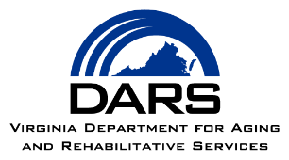
Survey of Individuals Receiving Aging Services

Virginia Commonwealth University Partnership for People with Disabilities (VCU-PPD) and the Virginia Department for Aging and Rehabilitative Services (DARS) is conducting a survey of Area Agency on Aging (AAA) clients across Virginia.

The aim of the National Core Indicators-Aging and Disabilities (NCI-AD) Adult Consumer Survey is to gather information about the services that AAA clients receive, their needs and preferences, and their quality of life.

A random sample of AAA clients across Virginia will be selected for the survey and contacted by VCU-PPD staff. The NCI-AD survey is administered by VCU-PPD staff over the telephone. Participating in the survey is voluntary and completely anonymous.

Your voice matters! If you are contacted by VCU-PPD, please consider participating.

If you have any questions, you may contact [AAA LIAISON NAME] by phone at [PHONE NUMBER] or email [EMAIL ADDRESS]. Information about the NCI-AD Adult Consumer Survey can also be found at this website: http://www.nci.partnership.vcu.edu.

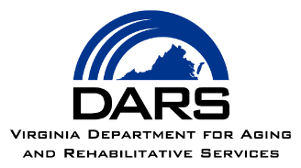

Survey of Individuals Receiving Aging Services

Virginia Commonwealth University Partnership for People with Disabilities (VCU-PPD) and the Virginia Department for Aging and Rehabilitative Services (DARS) is conducting a survey of Area Agency on Aging (AAA) clients across Virginia.

The aim of the National Core Indicators-Aging and Disabilities (NCI-AD) Adult Consumer Survey is to gather information about the services that AAA clients receive, their needs and preferences, and their quality of life.

A random sample of AAA clients across Virginia will be selected for the survey and contacted by VCU-PPD staff. The NCI-AD survey is administered by VCU-PPD staff over the telephone. Participating in the survey is voluntary and completely anonymous.

Your voice matters! If you are contacted by VCU-PPD, please consider participating.

If you have any questions, you may contact [AAA LIAISON NAME] by phone at [PHONE NUMBER] or email [EMAIL ADDRESS]. Information about the NCI-AD Adult Consumer Survey can also be found at this website: http://www.nci.partnership.vcu.edu.

