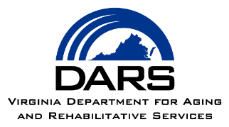

EMAIL TO AAA STAFF

FROM: NCI-AD AAA LIAISION

TO: AAA STAFF

SUBJECT: Survey of Individuals Receiving AAA Services

MESSAGE:

Colleagues,

In partnership with Virginia Commonwealth University Partnership for People with Disabilities (VCU-PPD), the Virginia Department for Aging and Rehabilitative Services (DARS) is conducting a survey of Area Agency on Aging (AAA) clients across Virginia.

This email is to inform all AAA staff about the National Core Indicators-Aging and Disabilities (NCI-AD) Adult Consumer Survey in case you are contacted by survey participants.

The aim of the NCI-AD survey is to gather information about the services that AAA clients receive, their needs and preferences, and their quality of life. The survey is part of the national effort and will be used to inform statewide planning efforts.

A random sample of AAA clients across Virginia will be selected for the survey and contacted by VCU-PPD staff. The survey is administered by VCU-PPD staff over the telephone. Participating in the survey is voluntary and completely anonymous.

UPDATE: VCU will now start reaching out to selected AAA clients in November.

Attached is a flyer that has additional information about the NCI-AD survey effort in Virginia.

As opportunities arise in the course of your work, please offer credibility for the survey and encourage AAA clients to participate.

If you or our AAA clients have any questions about the survey, I am available by phone at [PHONE NUMBER] or email [EMAIL ADDRESS].

Information about the NCI-AD Survey can also be found at this website: http://www.nci.partnership.vcu.edu.

Thank you for your help!
[AAA LIAISON NAME]

