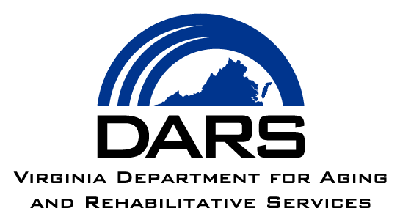

Dear [INSERT NAME],

You have been chosen to participate in a survey of people who receive Older Americans Act services in Virginia!

Examples of Older Americans Act services you may be receiving from [INSERT AAA NAME] include meals delivered to your home or meals provided in a group setting, transportation to a senior center, help with chores and other tasks around the house, or adult day services.

Why should I complete this survey?

The Virginia Department for Aging and Rehabilitative Services (DARS) and Virginia’s 25 Area Agencies on Aging want to learn more about your experiences receiving Older Americans Act services and your quality of life. The survey is part of the National Core Indicators-Aging and Disabilities (NCI-AD) Adult Consumer Survey. The information you give about your experiences is very important to Virginia, DARS, and to all people who use Older Americans Act services!

What will happen next?

- An interviewer from the Virginia Commonwealth University (VCU) Partnership for People with Disabilities will call you to schedule and complete the survey by phone.

- You can pick the date and time that works best with your schedule. Someone you know can be with you during the survey.

- The survey is optional and will take about 45 minutes to complete. Your survey answers will be kept private and will be combined with other people’s answers to create reports.

- You do not have to answer questions if you do not want to. Your survey answers will not change the services you are getting now or in the future.

What if I have questions?

If you have questions, you may contact VCU by leaving a message by phone at 833-462-2983 or send an email to ncivirginia@vcu.edu. You may also contact Charlotte Arbogast, the DARS project coordinator, by phone at 804-662-7093 or email charlotte.arbogast@dars.virginia.gov.

